CURRICULUMVITAE
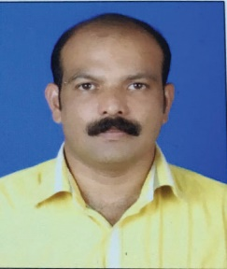
NAME: SUNIL

Email: SUNIL.333640@2freemail.com
OBJECTIVE:
To pursue a rewarding career in an organization that offers a challenging work environment, where my skills will be used to achieve organizational and personal goals and to create a platform and utilize my acquired knowledge to the best of my ability for the benefits of the organization and individual.
SUMMARY OF EXPERIENCE:
- 19 years in M/s Al-Watania Distribution Company as Salesman cum driver.
- 21 months in M/s. Grand Transport Company as Driver.
PROFESSIONAL EXPERIENCE:
Worked as Sales & Driver from 1995 to 2014– M/s. Al-Watania Distribution Company, Riyadh(KSA).
Worked as Driver from 2014 to 2016 – M/s. Grand Transport Company, Dubai, UAE.
PERSONAL STRENGTH:
- Capable of making a creative input in to business development
- Mature and confident with an ability to work under pressure
- Self-driven and highly motivated with a talent to make things happen
- Professional attitude and strong commitment to the job
- Exceptional administrative and organizational skills
- Well known UAE

EDUCATIONAL QUALIFICATION:
Pre-Degree in Economics (Mahathma College Thalassery)

ADDITIONAL QUALIFICATION:
Computer Knowledge
Knowledge of MS Word, MS Office and MS Excel, Knowledge of Internet.
PERSONAL DETAILS:
Nationality : Indian
Date of birth : 22-08-1971
Sex : Male
Marital status : Married
Religion : Hindu
Languages : English, Arabic, Hindi, Malayalam, Tamil
DRIVING LICENSE DETAILS:
- Date of Issue: 08-07-2015
- Expiry date: 15-07-2025
- Place of Issue: Dubai
- Job Preference: Light Vehicle Driver
- Job Type: Permanent
- Visa Status : Job Visa

I hereby declare that the above furnished information is absolute according to the records and to the best of my knowledge.

