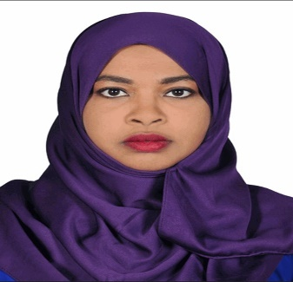
CURRICULUM VITAE
TAQWA
TAQWA.333644@2freemail.com
MBBS – General Practitioner
Step 2 USMLE – Clinical Skills - USA
Part I of Obstetrics and Gynecology MD -Sudan Board
HAAD Passer as General Practitioner –

A trusted, patient focused and experienced General Practitioner with a long history of serving patients by successfully diagnosing, treating and also managing their illnesses and diseases. Easy going by nature and able to get along with other healthcare professionals and also senior managers. Looking for and willing to consider suitable positions in either the private sector or governmental health bodies.
Seeking for opportunity to work as medical professional in a reputable hospital and utilize my professional skills to improve client satisfaction for the benefit of the organization.
To join a reputed and growth oriented Health organization/Hospital to challenge my skills and techniques, to work with various types of patients and to enhance my reputation as an excellent

QUALIFICATION
- MBBS - BACHELOR OF MEDICIN AND SURGERY
- JUBA UNIVERSITY – KHARTOUM – SUDAN
- YEAR OF COMPLETION: 2010
CONTINUOUS DEVELOPMENT
- BLS Course, 2016
- ALS Course, 2016
- ALSO Course, 2016
- Venous thromboembolism work shop 2012
- women health development course 2013
LICENSES
- HEALTH AUTHORITY – ABU DHABI –
- SUDAM MEDICAL COUNCIL LICENSE
OTHER INFORMATION
- Computer Skills • Arabic Language
- Team Work • English Language
- Continuous Development • Work under pressure
JOIN DATE
- IMMEDIATELY
PROFESSIONAL EXPERIENCE
From March /2015 to Date (Ministry of Interior – Khartoum – Sudan)

Sahiroon Specialised Hospital
Street: Burri P.O. Box 11560
SD- Khartoum
General Practitioner
From Aug /2015 to Feb/2016 (Sudan Medical Specialization Board)

Um Dawnpan Hospital
Khartoum East - Sudan
Registrar OBS/GYN
From Apr /2012 to Apr/2013 (Ministry Of defence - Sudan)
Military Hospital
Omdurman – Sudan

General Practitioner
From Dec /2011 to Apr/2012 (Ministry Of Health - Sudan)
ENT Hospital
Khartoum – Sudan

General Practitioner
From Sep /2010 to Oct/2011 (Ministry Of Health - Sudan)
Internship
Khartoum – Sudan

General Practitioner
House officer
PERSONAL INFORMATION
- DATE OF BIRTH: - 1986/10/14 • GENDER: - FMALE
- RELIGION: - MUSLIM • NATIONALITY: - USA
• MARITAL STATUS: - MARRIAGE • VISA STATUS: - RESIDENT

