  - 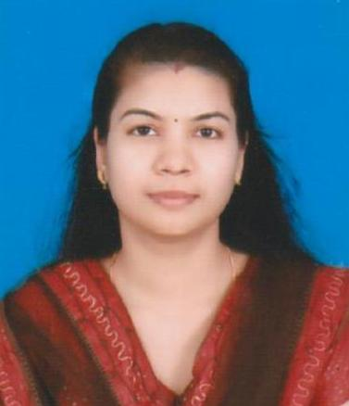

DIXY
DIXY.333673@2freemail.com

Career Objectives

A position that will build on my skills and experience that allows me scope for upward movement and better prospects in nursing profession.

Total years of experience : 10 Years

Sex & Date of Birth | : | Female, 13th November 1984
Nationality | : | Indian
Religion | : | Christian
Marital Status | : | Married
Passport Details | :
 |  | Date of Issue |  |  | : | 30/05/2012
 |  | Date of Expiry |  |  | : | 29/05/2022
 |  | Place of Issue |  |  | : | MUSCAT
Profession | : | Regd. Nurse & Regd. Midwife  OMAN MOH Licence  KNC Reg.No-  TNAI Reg .No  ACLS, BLS (CPR&AED)  Dubai MOH Passed. Liscence under processing.
Professional Qualification & Registration

Qualification | Institution | Year
General Nursing and Midwifery | Pushpagiri School of nursing,  Thiruvalla,Kerala | 2002/2005
Professional Registration | Kerala Nurses and  Midwives council | 2006
Academic Qualification
Qualification | Institution | Year
Secondary School leaving Certificates | M.M.A.High School,Maramon | 2000
Higher Secondary Examination | St.Johns Higher secondary school.  Eraviperoor,Thiruvalla. | 2002

Employment History
1.Employer : Kalliyath Hospital
Pookkayil Post, Tirur- 676107
Malappuram Dist., Kerala
Period : 05/08/2015 to 29/10/2016
Position Grade : Staff Nurse
Type of Unit : Surgical ICU

2. Employer : Badr Al-Samaa Group of Hospitals and
Polyclinics, Barka, P B No- 516
P C No-320, Sultanate of Oman
Period : 30/09/2009 to 07/07/2015
Position Grade : Staff Nurse
Type of Unit : Emergency And Trauma Care

3. | Employer | : | Pushpagiri Medical College Hospital,  Thiruvalla, Kerala
 | Period | : | 16/03/2006 to06/05/2009
 | Position Grade | : | Staff Nurse
 | Type of Unit | : | SICU &GENERAL SURGERY WARD

Additional Professional Assignments
❖ Community Health Nursing Service on Activities Special Rural Health Care Assignments.
❖ Pulse Polio Vaccination in National wide programme for child health and care.
❖ Psychiatric Nursing Assignments.

Clinical Work Experience
During Student Period
1. | Medical ICU | 7. | Surgical ICU
2 | Cardiology CCU | 8 | Operation Theatre
3 | Neuro ICU | 9 | Paediatric ICU
4 | Neonatal ICU | 10 | Medical Wards
5 | Surgical Wards | 11 | ENT
6 | Psychiatric Department | 12 | OPD

Duties and Responsibilities

➢ Functions independently in providing care to specific number of General Medicine Patients.
➢ Set priorities and implementing nursing care based on nursing process approach.
➢ Evaluating the outcome.
➢ Managing the emergency situation.
➢ Carry out the doctors order making rounds administer medication, co ordinate units, activities, referring patients, explanation of procedures maintenance of therapeutic environment.
➢ Give health teaching and provide information regarding home care health promotion, prevention if recurrence and reduce the complication.
➢ Maintenance of records and reports.
➢ Orientation and clinical teaching to new personals.
➢ Monitoring ECG, Pulse Oxymeter.

Activities and procedures Performed
➢ Admission of the patients and orientation of units
➢ Monitoring Vital Signs
➢ Emergency resuscitation
➢ Blood Transfusion
➢ Tracheostomy care
➢ Nasal/Tracheostomy/Oral sunction.
➢ CVP Care and Monitoring
➢ ICD Care
➢ Nebulization and Oxygen Therapy
➢ Catheterization, Catheter care
➢ Wound Dressing
➢ Suture removal
➢ IV Insertion
➢ Ryles Tube Insertion, Ryles Tube Feeding
➢ Application of Shoulder Brace
➢ L.S. Belt
➢ Cervical Collar
➢ Gastrostomy Feeding
➢ Jejunostomy Feeding
➢ Pre and post- operative care

Equipments Handled
•1 Ventilator
•2 Defibrillator
•3 Pulse Oxymeter
•4 Cardiac Monitor
•5 Gluco Meter
•6 Syringe Pump
•7 Nebulizer
•8 Laryngo Scope
•9 Opthalmo Scope
•10 Proto Scope
•11 Thermometer
•12 Sphygmomanometer
•13 Ambubag
•14 Airway

General
Language Proficiency | : |  | English, Hindi, Malayalam, Tamil, Arabic
Hobbies | : |  | Reading to keep knowledge updated  Listening to music and singing songs.
Declaration
I hereby declare that the above mentioned details are true to the best of my knowledge and belief.

