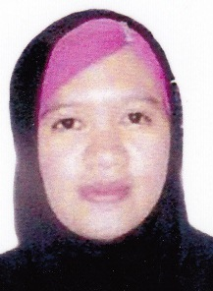
NURAINIE
NURAINIE.333684@2freemail.com

Objective:
Seeking a registered Midwife position in long care terms setting.Special interest in Neonatal intensive care unit, delivery Room/Birthing Clinic, Prenatal Clinic. Strengths includes:

- Remain calm under pressure
- Analytic, Reliable, Mature
- Considerable length of years in clinical experience.

Professional Summary:
Driven RM with over 3 years’ experience in Hospital and 6 months in clinic, providing comfort, support and knowledge in medical-midwifery care.Able to converse efficiently with patients, families, visitors, healthcare team, physicians and management.Comprehensive knowledge of professional nursing theory, clinical practice standards normal fetal growth and progress.Demonstrated ability to record assessments and interventions.Able to prepare reports and presentations.Hard worked as a Staff Midwife in our primary hospital with 100 bed capacity.Also experienced in cooperating and collaborating with various members of the health care team and in creating competent and effective nursing plans.

Personal information:
Age : 27 years old
Date of Birth : November 8, 1989
Place of Birth : Zamboanga City
Gender : Female
Marital Status : Married
Citizenship : Filipino
Height : 4 ,9
Weight : 45 Kg.
Religion : Islam
Languages/Dialect: English & Tagalog

Person to be contacted in case of emergency
Address : Ajman

Educational Background:
- Primary : Mampang Elementary School
Year Graduated: 2003

- Secondary : Zamboanga City High School main (ZCHS main)
Year Graduated 2007

- College : Brent Hospital College Inc.
Year Graduated: 2012
Midwifery

Employment Record:

- Oct.1, 2012 up to Sept. Staff Midwife
11, 2015 Ballaho Medical Hospital

- Nov 23, 2015 up to May
25, 2016 Well-Family (Midwife Clinic )

I hereby certify that the above information is true and correct to the best of my knowledge and belief.

