C U R I C U L U M V I T A E
Name | Enen
Date of birth | Purwakarta, 6 Juni 1982
religion | Islam
graduated | Bachelor degree at Pharmacy
Email | Enen.332626@2freemail.com
Personal id 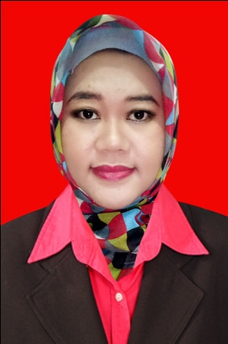

Educational background
Year in | Year out | School Name | city
1988 | 1994 | SDN Kapten Halim II | Purwakarta
1994 | 1997 | SMP Indorayon | Tapanuli Utara
1997 | 2000 | SMUN 2 Plus Matauli | Sibolga
2000 | 2006 | Padjadjaran University, Pharmacy Faculty | Bandung
Working experience
YEAR | COMPANY | POSITION | JOBS DETAIL
2003 | PT Panorama indah | Marketing propety | - Convincing prospective clients that your agency is the right one to handle their sale and agree the terms  - Arranging advertising to promote the property  - Sending out details of new properties on the market to people on your database  - Making appointments and showing buyers around a property  - Finding buyers in a position to proceed with purchase and willing to pay an acceptable price  - Refering buyers to mortgage arrangers for quotations and advice
2004-2005 | Bimbel Privat Cendekia | Staff | teach a range of subjects from the basics of English, math and science,
2007 | PT Organon Indonesia | Medical Representative | • arranging appointments with doctors, pharmacists and hospital medical teams, which may include pre-arranged appointments or regular 'cold' calling;  • making presentations to doctors, practice staff and nurses in GP surgeries, hospital doctors and pharmacists in the retail sector. Presentations may take place in medical settings during the day, or may be conducted in the evenings at a local hotel or conference venue;  • organising conferences for doctors and other medical staff;  • building and maintaining positive working relationships with medical staff and supporting administrative staff;  • managing budgets (for catering, outside speakers, conferences, hospitality, etc.);  • keeping detailed records of all contacts;
2008-2009 | PT Otsuka Indonesia | Medical Representative | arranging appointments with doctors, pharmacists and hospital medical teams, which may include pre-arranged appointments or regular 'cold' calling;  • making presentations to doctors, practice staff and nurses in GP surgeries, hospital doctors and pharmacists in the retail sector. Presentations may take place in medical settings during the day, or may be conducted in the evenings at a local hotel or conference venue;  • organising conferences for doctors and other medical staff;  • building and maintaining positive working relationships with medical staff and supporting administrative staff;  • managing budgets (for catering, outside speakers, conferences, hospitality, etc.);  • keeping detailed records of all contacts;
2009-2014 | PT Merck, Sharp and Dohme | Professional Sales Representative | arranging appointments with doctors, pharmacists and hospital medical teams, which may include pre-arranged appointments or regular 'cold' calling;  • making presentations to doctors, practice staff and nurses in GP surgeries, hospital doctors and pharmacists in the retail sector. Presentations may take place in medical settings during the day, or may be conducted in the evenings at a local hotel or conference venue;  • organising conferences for doctors and other medical staff;  • building and maintaining positive working relationships with medical staff and supporting administrative staff;  • managing budgets (for catering, outside speakers, conferences, hospitality, etc.);  • keeping detailed records of all contacts;
2014-NOW | PT. TROPICA MAS PHARMACEUTICALS | DISTRICT SALES MANAGER | Manages and directs a sales force to achieve sales and profit goals within a district. Designs and recommends sales and marketing programs and sets short- and long-term sales strategies. Requires a bachelor's degree in a related area and at least 4 years of experience in the field. Familiar with a variety of the field's concepts, practices, and procedures. Relies on experience and judgment to plan and accomplish goals. Performs a variety of tasks. Leads and directs the work of others. A wide degree of creativity and latitude is expected.ZZ reports to a regional sales manager.

