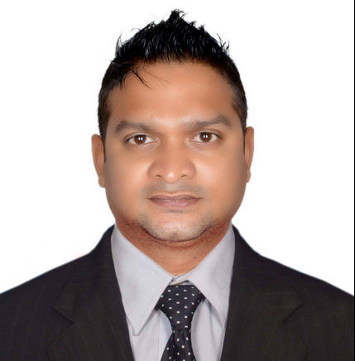

larson
objectives |  | Looking for a challenging post wherein I can utilize my skills and abilities to the best in order to obtain the overall target of the company and thereby enhancing my knowledge which would enable sustainable personal growth.
Skills & Abilities |  | - Outstanding guest/employee relations and communication skills.  - Extraordinary time management and organizational skills.  - Superb proactive attitude to work.  - Strong ability to promote superior quality customer service, cleanliness and safety.  - Strong ability to solve practical problems effectively with internal and external customers  - Ability to calculate figures and amounts, proportions, percentages, and volumes to track inventory and controls.
Professional Experience |  | BAR SUPERVIOSOR AT AVENUE HOTEL DUBAI UNITED ARAB EMIRATES.  13TH SEPTEMBER 2014 TILL DATE  - Careful mix logy of the drinks.  - Proper micros and cash transaction for the exchange of drinks as well as food served for guest.  - Upkeep and maintenance of bar tools as well as keeping the track of their inventory.  - Assisting bar captain or manager for the inventory purpose.  - Providing the guest maximum support and service as per the hotel standard.  - Help the team in all areas of the bar when necessary.  - Interaction with guests and answer all bar and hotel related questions.  - Attention to detail and ability to maintain a highly hygienic environment.  - Ability to conduct multiple tasks and work under pressure.  - Ability to maintain good relationship with clients.  - Maintain good relation with the fellow workers behind the bar also paper works of the bar after the closing especially entering revenue and 22 report also FMC for the issue of stores in the system.  BARTENDER, DUBAI mARINE beach resort & spa  10 MAY 2014 TILL 12 AUGUST 2014 – WORLD CUP EVENT SOCCOR  - Responsible for assisting restaurant manager in the supervision of whole food and beverage operation  - Provided excellent guest satisfaction and increased productivity standards by utilizing available resources  - Scheduled and trained employees and ensured proper coverage  - To inform about daily events, conducted pre-shift meetings of employees  - Supervised check or credit policies and procedures and cash handling.  bartender, four points by sheraton - STARWOOD properties  MAY 2013 to APRIL 2014  - Take beverage orders from servers or directly from guests or patrons  - Collect cash for beverages or drinks served and record sales  - Maintain record and control of bar stock and arrange supplies  - Mix drinks, water and other components to get ready cocktails and other drinks  - Order bar supplies  - Place bottled merchandise and glasses to make a smart display  - Serve snacks to patrons seated at the bar  others  February 2004 to April 2013  - Worked with Carnival Co-operation cruise ship (Ocean Village) United Kingdom as a bartender from December 2007 to March 2013  - Worked with F&B in a Italian Lounge bar as bartender in Bangalore from January 2007 to November 2007  - Worked with Hotel Intercontinental as an Bartender from October 2005 to December 2006  - Worked with Albert Abela Catering Company, Sharjah International Airport as Restaurant Captain from September 2004 to September 2005  - Worked with “Swapna Nagari Holiday Resort”, Mumbai (India) as Bar Waiter from February 2002 to August 2004  - Worked 06 months in Industrial Training with Ambassador hotel Church gate Mumbai
Education |  | SATYAWATI SOIRU JUNIOR COLLEGE – HSC, 2001  ST. RITA HIGH SCHOOL – SSC, 2000  Hotel Management & Catering Technology from Kohinoor Hospitality Management School, Mumbai (India)
ADDITIONAL |  | - Service Culture Training conducted by Starwood Properties.  - Food and hygiene course conducted by Dubai Municipality, UAE.  - Intermediate Food & Hygiene course on Cruise – United Kingdom  - Responsible Service of Alcohol certificate on Cruise – United Kingdom  - Integrated Pest Management (Nutrastat) – United Kingdom  - Have a valid Seaman’s Discharge book – United Kingdom of Great Britain and Nothern Ireland.  - Completed (STCW) Standards of Training, Certification and Watchkeeping for Seafarers Courses in following:  - Personal Survival Technique  - Personal Safety & Social Responsibility  - Fire Prevention & Fire Fighting  - Elementary First Aid  - Survival Craft and Rescue Boat other then Fast Rescue Boat  - Passenger Ship Familiarization (Crowd and Crisis Management-Operational Level)  OTHER ACHIEVEMENTS  Dubai, United Arab Emirates.  - Participated in Chivas Training with the distiller Mr. Collin Scott conducted by PATH BAR SCHOOL, Dubai, United Arab Emirates.  - Participated in Mosco mule training program conducted by PATH BAR SCHOOL, Dubai, United Arab Emirates.  - Participated in Monkey Shoulder single malt training program conducted by PATH BAR SCHOOL, Dubai, United Arab Emirates.  - Participated in Hendrix Gin training program conducted by PATH BAR SCHOOL, Dubai, United Arab Emirates.  - Participated in Johnnie walker training program conducted by PATH BAR SCHOOL, Dubai, United Arab Emirates.  - Participated in Glenfiddich single malt training program conducted by PATH BAR SCHOOL, Dubai, United Arab Emirates.  - Participated in Bacardi training program conducted by AFRICIAN EASTERN, Dubai, United Arab Emirates.

yours sincerely
Larson

