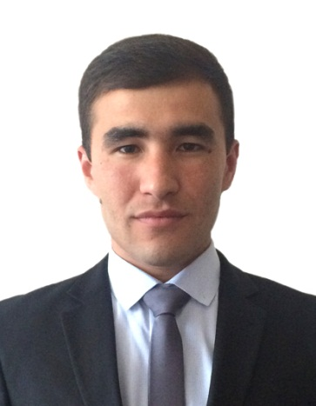
HAZIRDINOV
HAZIRDINOV.333793@2freemail.com

QUALIFICATIONS
EDUCATIONAL BACKGROUND
Years | Place of Study | Degrees | Address
2010-2014 | Uzbek State University of World Languages  III-English Philology faculty | Bachelor’s Degree | 21-a, G-9a District, Kichik halqa yo’li Street, Tashkent City 100138
2001-2010 | №40 specialized school | Secondary School Certificate | Kho’djaabad District Andijan Region Uzbekistan
2000-2001 | School №12 |  | Kho’djaabad District Andijan Region Uzbekistan

EXPERIENCE
Years | Place of work | Address | Duties
2015 September - | NOU “Dobona” Study Center | 18/21 Chilanzar District, Tashkent City | Marketing Manager
2015 September - 2016 October | №3 Academic Lyceum under TDTU | 54,Gyote St, Mirzo Ulug’bek Region,  Tashkent City | English Teacher and Supervisor
2014 October – 2015 August | NOU “Study Abroad” Study Center | 4, Beruniy Street, Olmazor Disrict, Tashkent City | English Teacher and Business English Teacher

SKILLS
Skills
Languages:  Uzbek  English  Russian  Korean  Arabic | Native  Advanced  Intermediate  Elementary  Elementary

ACHIEVEMENTS
Years | Achivements
2009 | Winner of regional Geography Olympiad
2010 | Winner of regional Geography Olympiad, Attendant of Republic Olympiad
2010 | Winner of School Football Championship
2010 | Winner of Regional “Brain Ring” Intellectual contest
2012 | Attendant of regional Chess Championship
2015 | Volunteer interpreter in Junior World Fencing Championship in Tashkent
2015 | IELTS Certificate band 6.5
2016 | Winner of the most supportive supervisor of the year in №3 Academic Lyceum under TDTU

INTERSTS
- Reading Books: Adventure, Fantastic, Detective, Scientific Fiction, Historical
- Playing Chess, Football
- Watching Movies: Scientific Fiction, Fiction, Adventure, Detective
- Watching Football matches

