AMALA
AMALA.333815@2freemail.com
An achievement-driven professional targeting senior level assignments in IT Project Management and Execution
Location Preference: Dubai / Sharjah

Key Skills Profile Summary

IT Project Management

Software Development Life Cycle Programming & Implementation ETL Testing
Talend Implementation

Client Relationship Management Software Installation
Delivery Management
A goal-oriented professional with nearly 6 years of experience in IT Project Management and Software Installation
Expertise in managing overall software development life-cycle involving requirement analysis, system study, designing, architecture, testing, programming, coding, de-bugging, defect management & documentation
Proficient in technical project management including scheduling & negotiating with clients for iterative product development and delivery, balancing work distribution to meet project deliverables & delivery as per quality & time norms
Excellent track record of designing customised IT products for high profile clients; capability to interface with clients, suggest viable software solutions, cultivate relations with them for securing repeat business
Hands-on-experience in analysing information system needs, evaluating end-user requirements, custom designing solutions and troubleshooting for complex information systems management
An effective communicator with relationship management skills with the capability to relate to people at any level of business and management

Team Building

Education
    - rom St. Ann’s PG College, Hyderabad, Osmania University in 2010 with 63.8% B.Sc. from Aurora Degree College, Hyderabad, Osmania University in 2007 with 72%

Certification
Talend Open Studio Certified user in 2011

Career Timeline

Decision Technologies Pvt.
Ltd., Hyderabad Associate Software Developer
Saama Technologies, Pune
Associate Consultant

Dec’10 – Dec’11

Jan’12 – May’14
Jul’14 – Feb’15

Mar’15 – Present

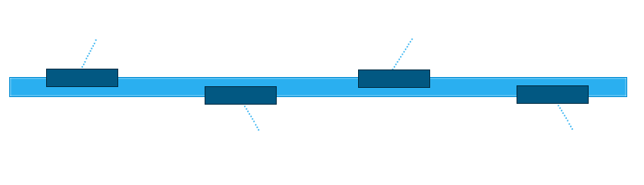
Landmark IT Solutions Pvt. Ltd., Hyderabad Talend Developer

Cognizant Technologies, Pune Associate

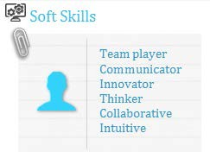IT Skills
      - Languages : C, C++, JAVA
      - ETL Tool : Talend 4.0, 4.1, 5.0,6.0,6.1,SSIS, Talend MDM ,DQ
      - Database : Oracle 10g, MYSQL, SQL Server, Big Query
      - Operating Systems : Windows-XP, Windows Server 2008 R2
      - Web Technologies : HTML, Java Script, XML
      - Integration Tools : Biz Talk Server 2010

Work Experience
Cognizant Technologies, Hyderabad from Mar’15 – Present as Associate

Saama Technologies, Pune from Jul’14 – Feb’15 as Associate Consultant(L2)

Landmark IT Solutions Pvt. Ltd., Hyderabad from Jan’12 – May’14 as Sr. Talend Lead

Decision Technologies Pvt. Ltd., Hyderabad from Dec’10 – Dec’11 as Associate Software Developer

Key Result Areas:
Managing software development including design, development & troubleshooting of applications; conducting gap analysis including validation of needs in conjunction with onsite & offsite teams
Reviewing EQ for the data analysis and cleansing data in data integration
Administering TAC – Talend Administrative Center, Talend Data Quality Portal and Data Stewardship Portal Facilitating implementation of the product with documentation and execution of varying sizes of customizations, implementation of standard processes and maintenance & up-grading existing product
Undertaking development & testing, defect & issue management for software applications; conducting reviews of codes & test cases and analysing change requests / enhancements
Driving vision / roadmap & life-cycle management for software applications (e.g. SRR) including value proposition & functionality, strategy elements (domain, business case) and training
Analysing user requirements to identify trends and resolve performance issues; preparing proposals, delivering business presentations to clients and managing resource planning, effort estimation & risk management
Steering the successful rollout of projects with defining scope, setting timelines, analysing requirements, prioritising tasks, identifying dependencies and evaluating risks & issues as per budgets
Monitoring project progress & outstanding issues and ensuring the quality & timeliness of the deliverables; preparing monthly dashboard, project health check metrics and weekly & fortnightly status reports as well as extending post- implementation support to team members by identifying defects, inconsistencies & errors
Organize training session in Talend within the company as per the requirement Conducting technical interviews

Significant Accomplishments:
Recipient of company core values during 2012 to 2013

Personal Details
Date of Birth: 25th April 1987
Languages Known: English, Hindi and Telugu

Please refer to the Annexure for Project Details:

ANNEXURE

Project Title: Inmarsat
Period: Mar’16 – Present

Responsibilities:
Complete initial setup and Installation
Functional and Technical Logic and Job designing. Generated DQ Reports for the data Analysis Cleansing data in Data Integration
Worked on TAC (Administration),Talend Data Quailty Portal and Data Stewardship Portal

Project Title: Anti money laundering(AML)
Client: CITI Bank
Period: Mar’15 – Mar’16
Role: Talend Developer

Responsibilities:
Managing the entire gamut of operations including Technical Logic, Job Designing and Custom Routines Leading the complete set-up in UNIX, Autosys and ensuring the complete backup process in SVN and TAC Using DIF framework for automation process files and UDeploy & Hermes For build Process

Project Title: Remington & Ashford
Client: Remington
Period: Jul’14 – Feb’15
Role: Talend Developer

Responsibilities:
Supervised operations including requirement study, design and development Initial setup and installation
Performed functional, technical logic and job designing
Managed different sources and used TAC (Administration) and automation of complete process

Project Title: Catalogues Designing and Implementation
Client: Uniform Market
Period: Jan’12 – May’14
Role: Talend Developer

Responsibilities:
Implemented more than 200 catalogues using Talend Initial setup and installation
Importing the Catalogues from the FTP location
Functional and Technical implementation of Catalogues of different types Data cleansing and Images loading from the different sites to the Catalogues Gave Talend Training to Team
I done unit testing and front end testing after live

Project Title: Sales Automation Project
Client: Micrel
Period: May’11 – Nov’11
Role: ETL Developer

Responsibilities:
Involved in the Requirement study, design and development Installation of Talend Software
Store the Consolidated data into the SQL Server by calling the stored procedures. Consolidated the data and generated the reports using the data quality.
Created the Talend and Java Routines and cleansed the data. Created Source Schemas for different type of EDI Files.
Designed the workflow of the process using Talend MDM. Testing and Code review

Project Title: St. Jude’s Data Warehouse Implementation
Client: St. Jude Children’s Hospital
Period: Jul’11 – Nov’11
Role: ETL Developer

Responsibilities:

Analyzing the Data model.
Data Standardization and Validation by using Lookups Development of ETL Mappings and Transformations. Functional and Technical Logic and Job designing.
Data Consolidation

