SANKAR

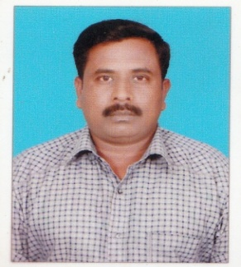

**Sankar**

DOHA,QATAR

E-mail: [sankar.333821@2freemail.com](mailto:sankar.333821@2freemail.com)



# Carrier Objective

Seeking a classical opportunity to serve in your esteemed organization and prove myself worthy in the uplift of the organization. And also need a position a constantly learn contribute and grow along with the organization.

# Employment History

I have gained **20 years and 6 months excellent professional experience** as Head Constable in Central Reserve Police Force in India.

# Skill Profile

* Havinggood experience in theAccounts / Security fields.
* Highly motivated and dedicated to teamwork. I have successfully undertaken various teams within both academic nonacademic environments.
* Flexibility and ability to adapt to changing situations.
* Ability to manage multiple tasks and meet tight deadlines and targets.
* Excellent Communication Ability; Good problem solving skills; Strong numerical and analytical skill; Excellent Interpersonal skills; Desire to work to full potential.

# Professional Qualification

|  |  |  |
| --- | --- | --- |
| **COURSE** | **UNIVERSITY** | **COURSE DURATION** |
| **Bachelor of Commerce** | C:\Users\nusri\Desktop\images.jpg | **3 Years** |

# Professional Experience

|  |  |
| --- | --- |
| **CENTRAL RESERVE POLICE FORCE.**  Government of India | |
| **Position** | **Head Constable** |
| **Period** | APRIL 1990 to November 2011 |
| **Duties and Responsibilities** | I did challengeable duty against terrorist, political rally ,Internal riots  Safety and Security Responsibilities of Public and Government Properties  As well as Forest Trees  Rescue and Rehabilitation work for Public Safety while Dangerous Situation as Earth Quake, Heavy Rain, Storm and all Natural Disaster  Good Experience with Clerical and Accounts work as related in the Police Department |

PERSONAL DETAILS

Name : **N. Sankar**

*Date of Birth : 05.06.1971*

*Marital Status : Married (2-children)*

*Visa Status : Business Visa(QATAR)*

*Place of Issue : CHENNAI*

*Issued Date : 13.01.2014*

*Expiry Date : 12.01.2024*

*Nationality : Indian*

*Languages Known :* English,Hindi,Tamil,Malayalam

# Declaration

I hereby declared that above mentioned details are true to the best of my knowledge and belief.

*Date; Signature*

*Place;DOHA,QATAR ( N.Sankar)*