- Date & Place of Birth Damascus 1970
- Visa Status UAE Residence Visa

Team leader and problem solver with long time experience of working with international organizations and private sector. Outstanding ability in administration, public relations, supervising and organizing events, such as conferences and international campaigns. Effective communication skills in building relationships with key stakeholders internally and externally. Distinguished capability of conducting researches, writing reports and handling various activities. Fluent in English and Arabic.

Seeking for a challenging position in a professional Organization where I can enhance my skills and strengthen them in conjunction with Organization’s goals.
Key Skills
Interpersonal Relations∼ Coordination & Communication ∼Management Skills
∼Results Orientation∼Document Use
Professional Experience
Trainer in the field of crisis management, safety & raising awareness
Translator (English-Arabic & vis versa)
Dubai 2016

Company for Consulting & Research IB / Syria 2015
Projects Administrator
IB is the only company licensed to address humanitarian relief and the impacts of the Syrian crisis on internal displaced persons IDPs and the aid provided by international organizations through studies and researches.

Responsible for supervising all projects related to implementing surveys and studies of the humanitarian relief. More specifically, my duties include:
- Training the team work on the tools of monitoring & evaluation.
- Compiling the results of the studies into official reports supported with recommendations to be presented to international organizations, research centers.
- Auditing the budgets and financial reports of the projects.
- Coordinating with international organizations, NGOs and the private companies to establish cooperation, joint work and exchange experiences.
Selected Contributions:
- Establishing a team work of 18 members in all regions.
- Providing successful surveys & studies to international organizations such as WFP, UNRWA, and UNICEF.
- Enhancing the credibility of the company which resulted in new contracts with international organizations and NGOs to implement studies & researches.

United Nations Development Program/ Syria 2006- 2014
PR& Awareness Officer
Strengthening Capacity Development for Disaster Risk Management is a project implemented by UNDP in Syria to address disasters risk reduction through improving infrastructures, capacity building and raising awareness.

Spearhead and implement the awareness strategy, addressing all segments of society proactively and with accountability. Manage and prepare events such as workshops, conferences, exhibitions. Manage daily issues such as meetings, dealing with media, preparing and translating reports.
Main responsibilities include:
- Supervising the global campaign of "My City is Getting Ready" through organizing activities, initiatives, and regional meetings & workshops.
- Coordinating with stakeholders to achieve joint cooperation and initiatives.
- Raising awareness of society towards safety and environmental issues.
Most important contributions:
- Integrating the concepts of disaster risk reduction in the schools'curriculums which address more than five millions students.
- Preparing a Poster (Safety in Prevention) to be distributed and displayed in 22.000 schools.
- Translating, reviewing and proofreading the international cooperation agreements towards natural disasters risk reduction and proposing the appropriate amendments.
- Preparing and publishing 3 awareness booklets about public safety and natural disasters which were selected as the best versions in Arabic language in exhibition of Third session of global platform for Disaster Risk Reduction, Geneva- Switzerland (2011).
- The selection of the project as a pilot project in the MENA region as a result of the success of adopting the criteria of the global campaign "My City is Getting Ready".
- Preparing documents in Arabic & English on the activities to be published on Printed & Electronic media.

Al Droubi Group for Construction & Supplying/Damascus/Syria 2004-2005
Officer in the Department of Researching & Contracting
Al Droubi Group is the largest company in the construction and equipment of electric power stations. It represents many European and Asian international companies.
Responsibilities:
- Preparing the contracts and correspondence with foreign companies.
- Conducting studies about companies that might lead to joint ventures.
Embassy of Malaysia/Damascus/Syria Septmeber2003- May2004  Chief of Clerks/ Marketing Officer  - Supervising and organizing the official visits of senior officials to Syria including the king of Malaysia visit to Syria in May 2004.  - Supervising all issues concerning the visits of official delegations (travel and itinerary arrangement), following up all issues related to promoting the cooperation between both countries (Syria and Malaysia).  - Attending the official meetings, taking memos and preparing minutes of meeting.  - Working for the promotion of Malaysian trade in Syria through coordinating and linking between companies & businessmen in the both countries. | 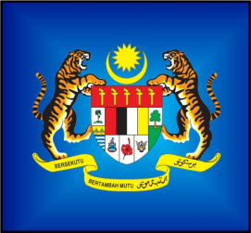
Ministry of Water Resources/Damascus/Syria 1997- August 2003  Officer in the International Cooperation Section  - Coordinating with international organizations to establish cooperation and joint projects.  - Supervising the launching conference & activities of United Nations Convention to Combat Desertification in the Middle East.  - Preparing documents, correspondence, reports and budgets of international projects.  - Supervising the implementation of field projects such as modern irrigation systems and installation of gauging stations.  - Supervising purchasing orders of supplies, facilities of the projects.  - Translating the reports and studies prepared by foreign & National experts from English to Arabic and vice versa. | 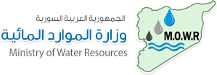
Al-Malki Company for Cargo & Tourism/Damascus/Syria 1996
Manager of Tourism Department
- Establishing the tourism department in the company.
- Preparing tour programs for groups & individual tourists.
- Making arrangements for catering, accommodation, transport and excursions.

Education & Professional Development
M.S. in International Economics  Damascus University (2014) | 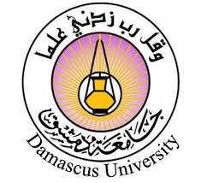
Bachelor of International and Diplomatic studies
Damascus University (2013)
Bachelor of English Language and literature
Damascus University (1994)

A course in business communication  American University of Beirut (2014) | 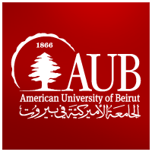
A course in crisis & disasters management  London International Academy (2012) | 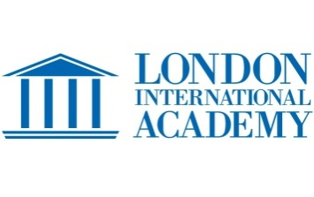
An internship in UNCCD (United Nations Convention to Combat Desertification) headquarters in Bonn - Germany in the field of capacity building and organizing conferences, workshops and promoting the cooperation among countries of the convention (2002) | 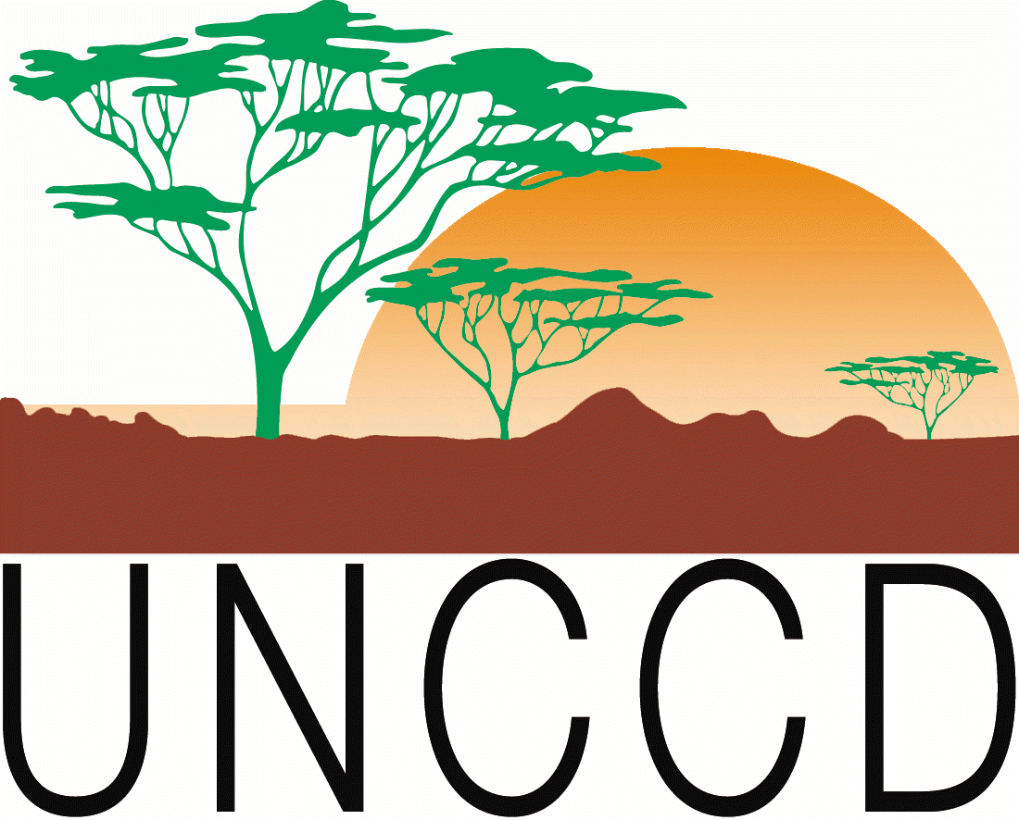
A Diploma in Translation  American Language Centre (1994) | 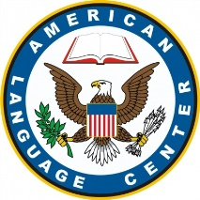

Affiliation Co-founder of the Environmental Protection & Sustainable Development Society, Damascus-Syria.
Publications Full list of publications will be provided on request.

Eyad Qatana-CV NO:2003028
To interview this candidate, please send your company name, vacancy, and salary offered details along with this or other CV Reference Numbers that you may have short listed from http://www.gulfjobseeker.com/employer/cvdatabasepaid.php
addressing to HR Consultant on email: cvcontacts@gulfjobseekers.com
We will contact the candidate first to ensure their availability for your job
and send you the quotation for our HR Consulting Fees.

