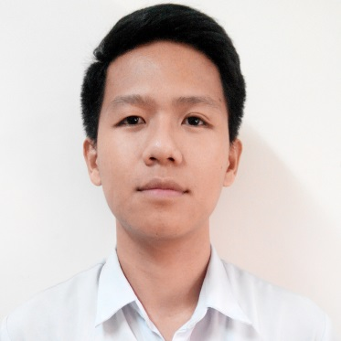

RUEL
RUEL.333856@2freemail.com

CAREER OBJECTIVES:
• To be able to work in the Institution where I will be able to boost my strength with the best of my knowledge and capabilities through comprehensive guidance with the means of enhancement.
• To provide quality health care to patients and maximize the effectiveness of healthcare facility.
• To be one of hard-working employee inside the Institution.
• To gain more experience to be competent individual.

PROFESSIONAL SKILLS:
• Interact with patients to figure out their physical and psychological needs.
• Identify patient actual and potential problems
• Devise treatment plans tailored to requirements.
• Maintain safety and precaution standards.
• Document all patient’s records and procedures.
• Collaborate with the appropriate doctors and nurses with respect.
• Provide health teaching to patients and families about conditions and appropriate plans of action
• Provide direct quality care and record/document all pertinent data about the condition of patient
• Good in therapeutic communication

WORKING EXPERIENCE:
• CITISUPER INCORP. (LANDMARK TRINOMA, QUEZON CITY PHILIPPINES)
Work as a INVERTORY CLERK
January 2010 to June 2010

• DR. JOSE N. RODRIGUEZ MEMORIAL HOSPITAL (TALA, CALOOCAN CITY PHILIPPINES)
Work as Nurse Trainee
Area assigned: OR, Female Ward, Pedia Ward, Medical Ward

• DR. JOSE N. RODRIGUEZ MEMORIAL HOSPITAL (TALA, CALOOCAN CITY PHILIPPINES)
Work as Staff Nurse
Area assigned: OR, ER, Medical Ward, Pedia Ward, PICU, NICU, ICU
June 16, 2014 to November 15, 2016

EDUCATIONAL BACKGROUND:
• COLLEGE EDUCATION
BACHELOR SCIENCE IN NURSING
(OUR LADY OF FATIMA UNIVERSITY AT LAGRO, QUEZON CITY PHILIPPINES)
2006 to 2011

• SECONDARY EDUCATION
NEW ERA HIGH SCHOOL
(TANDANG SORA AVENUE, DILIMAN, QUEZON CITY PHILIPPINES)
2002 to 2006

• PRIMARY EDUCATION
NEW ERA ELEMENTARY SCHOOL
(TANDANG SORA AVENUE, DILIMAN, QUEZON CITY PHILIPPINES)
1994 to 2004

TRAINING/SEMINAR ATTENDED:

• Intravenous Therapy Training
September 2013
St. Mattheus Medical Hospital
(San Mateo Rizal Philippines)

• Twenty-Hour (20-hr) Orientation Seminar on the revised, updated and expanded new trends on Breastfeeding Program.
July 1-3, 2014
(Dr. Jose N. Rodriguez Memorial Hospital, Tala, Caloocan City Philippines)

• “Wellness Program By Nurses: Vaccination” - Nurse Vaccinator
July 11, 2014
Home Health Care Inc.
(Anonas, Quezon City Philippines)

• Four-Hour (4-hr) Orientation on Infection Control Health Practices and Four-Hour (4-hr) Orientation on Health Care Waste Management
November 19, 2014
(Dr. Jose N. Rodriguez Memorial Hospital, Tala, Caloocan City Philippines)

• HIV/AIDS Seminar
April 24, 2015
(Dr. Jose N. Rodriguez Memorial Hospital, Tala, Caloocan City Philippines)

• National TB Control Program Seminar
April 24, 2015
(Dr. Jose N. Rodriguez Memorial Hospital, Tala, Caloocan City Philippines)

• Basic Life Support (Department Of Health)
July 15 & 16 2015
(Dr. Jose N. Rodriguez Memorial Hospital, Tala, Caloocan City Philippines)
-Scheduled my renewal of BLS on January 24 and 25 2017-

• 15 LEAD Electrocardiogram (ECG)
May 4, 2016
(Dr. Jose N. Rodriguez Memorial Hospital, Tala, Caloocan City Philippines)

• Orientation for Nurse Certification Program
May 12, 2016
(Dr. Jose N. Rodriguez Memorial Hospital, Tala, Caloocan City Philippines)

• Comprehensive Nursing Documentation “Way to Safe and Effective Nursing Documentation”
September 15 & 16, 2016
(Dr. Jose N. Rodriguez Memorial Hospital, Tala, Caloocan City Philippines)

I do hereby affirm that all the information here is all true and correct to the best of my knowledge.

