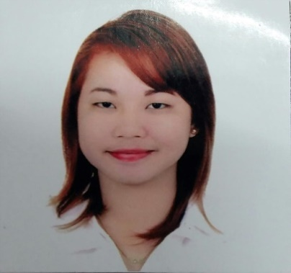
RIALENE
RIALENE.333859@2freemail.com

OBJECTIVE:
To gain experience and exposure, so i can acquire knowledge to any work-related task and improve my work ethics. And become a more proficient worker on any given field. I am a person who is susceptive to know ideas, believe and willing to undergo training. Also, an independent, hardworking adaptable in any kind of situation and capable to work under pressure.

OJT in Department of Agrarian Reform: with Certificate
- Encoding
- Documents
- Papers works

WORK EXPERIENCE:

Sales Lady
PenShoppe, Gaisano Mall
Start May 10,2015
End of August 15,016

PROFESSIONAL STRENGTHS

- Computer Hardware Servicing NC
CYTJ

Special Skills:

- Microsoft Windows Applications: MS Word, MS Excel, Adobe Photoshop& PowerPoint.
- Clerical/Secretarial jobs: Encoding, filling and documents & papers.

EDUCATIONAL ATTAINMENT:

Elementary : Pitogo Elementary School, Zamboanga Del Sur
School Year : 2004-2005
Secondary : Immaculate Conception High School
Pitogo Zamboanga Del Sur
School Year: 2010-2011
College: Eastern Mindanao College of Technology
Pagadian City
Course : Bachelor of Science in Information Technology
School Year : 2014-2015

PERSONAL INFORMATION:

Date of Birth : July 28, 1994
Height : 5’4
Weight : 55 kg
Citizenship : Filipino
Status : Single
Religion : Catholic
Gender : Female

I hereby certify that the above information is true and correct to the best of my knowledge and belief.

