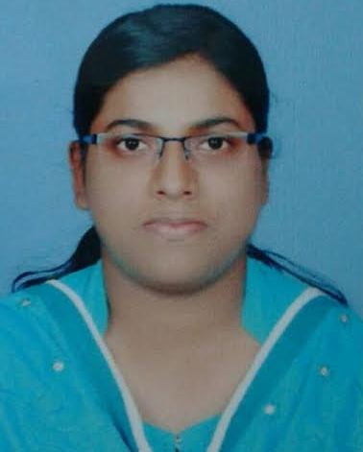
BLESSY
BLESSY.333882@2freemail.com

PROFESSIONAL SUMMARY
Highly skilled and analytical AAPC certified medical coding specialist has full understanding of ICD-10CM and HCPCS and CPT procedures. Significant experience working in hospital environments. Possesses thorough knowledge about human anatomy, physiology, treatment strategies, patient care along with data entry skills allows for accurate coding of medical information and provided care. Proficient in a variety of practice management software applications. Dedicated to maintaining strict patient confidentiality.

PROFESSIONAL QUALIFICATION

- MEDICAL CODING : CPC certified –AAPC (Membership ID : 01502158)
- STAFF NURSE : General Nursing and Midwifery (2009)
- WEB DESIGNING : Web designing (2011)

CORE COMPETENCIES

- Extensive knowledge of medical technologies across broad range of medical areas.
- Excellent computer skills in handling: Word, Excel, PowerPoint, Internet, Email, Social Medias.
- Excellent data entry skills.
- Basic knowledge of website designing.
- Good interpersonal skills and ability to function as a team member.
- Quick learner and adaptability to changing environments.
- Willing to shoulder challenges and responsibilities.
- Excellent in intensive care nursing.
EXPERIENCE

- Medical Coding Experience 3 Months from ITrans, Trivandrum
- Six months experience in intensive care nursing from Meditrina Hospital, Kottarakkara.
- One year experience in medical and surgical ward nursing from Pranavam Hospital, Punalur.
- Two years experience as office admin assistant and data entry operator, Peniel Computers, Bahrain.

ADDITIONAL INFORMATION
- Good team player
- Sincere and Hardworking
- Excellent interpersonal and Communication skills
- Strength to put across ideas

DECLARATION

I hereby declare that the above furnished information is true and correct to the best of my knowledge and belief.

