Sakkeer
Email: sakkeer.333937@2freemail.com

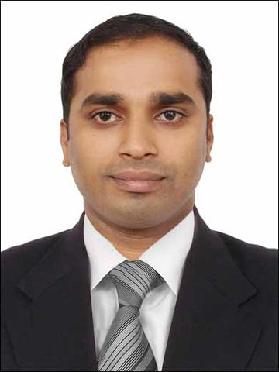
Career Objective
Developing as a comprehensive hospitality professional by acquiring training through various challenging assignments. To work for the best, excel professionally and to ensure success of self, peers and the organization.
Education
- Vocational Higher Secondary Education passed in the year of 1999
- Secondary school Leaving Certificate passed in the year of 1997
Work Experience

Presently working In the Marhaba lounge Dubai International Airport since 2nd December 2012 as a Customer service.

- Sales associates at Trefretelli General Trading in Dubai from May 2010 to October 2012
- Sales Executive at Brands General Trading in Dubai from September 2006 to August 2009
- Salesman at Silvio Oliverson in Dubai from September 2002 to January 2005

Achievement and Awards
- Completed Elementary Food Hygiene (Level-2) from The Royal Environmental Health Institute of Scotland. Completed in Dubai.
- Emirates Lounge experience course done from Emirates flight catering.
- Airport security awareness course- achieved from Emirates Security Group ,Dubai
- Basic computer knowledge in Application(excel, word, power point) and hotelier
- Attended Training for Airport Service Program.
- Attended Training for First Aider.

Additional skills
- Holding Light Motor Vehicle License (Valid UAE)

Area of Interest
- Customer Service, Sales department, Hospitality management

Strengths
- Self confidence and creativity
- Can Quickly Grasp and Learn New Technologies
- Good Communication and Presentation Skills, Easily
- Communicate Ideas and Concepts.
- Can easily guide others. Also a good team leader
- Work Collaboratively with Team Members to achieve
Common Goals and High Quality Deliverables.
- Ability to analyze problems/issues
PERSONNEL DATA

Date of Birth : 03.02.1980
Place of Birth : Kerala
Sex : Male
Nationality : Indian
Marital status : Married

LANGUAGE KNOWN:

English,
Arabic,
Malayalam,
Hindi,
Tamil.

Declaration
I hereby declare that the information which is given above is true to the best of my knowledge

SAKKEER
DUBAI.

