CURRICULUM VITAE

GOODWIN

E-mail :
GOODWIN.333967@2freemail.com

Personal Data:
Date of Birth | : | 14/05/1987
Sex | : | Male
Religion | : | Hindu
Nationality | : | Indian
Marital Status | : | Single
Visa Status | : Employment

Career Objective
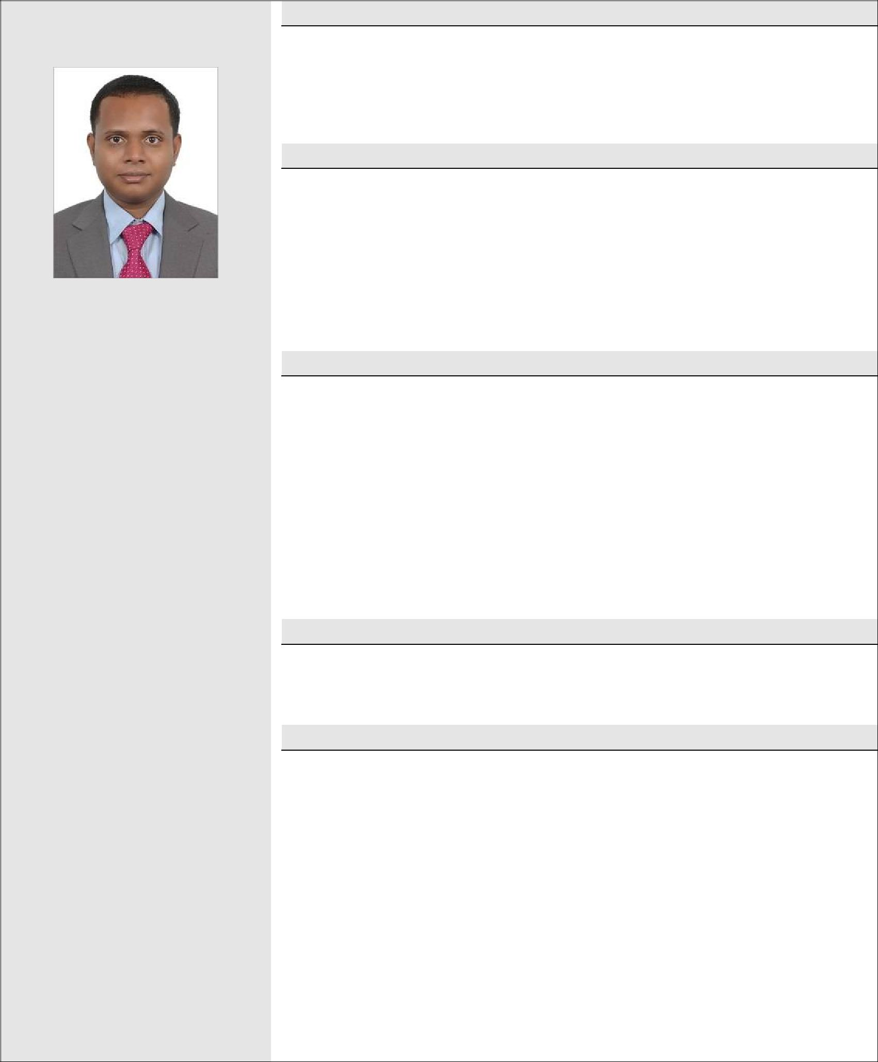

To work in a reputed company with the aim of contributing my efforts towards achieving its goals, which would at the same time help in enhancing my talents and bringing out my potential.

Educational Qualification

- B.Sc. Computer Science (Graduation, 2007 ) - 68.4%

- +2 (Higher secondary, 2004) - 52%

- SSLC (High school studies, 2002) - 67.8%

Experience Summary

- Working as System Administrator in MEDIATRON SYSTEMS LLC (surveillance systems) Installations & Troubleshooting, Dubai from May 2013.

- Worked as System Administrator for Logtech Info way Pvt. Ltd, Thiruvananthapuram (2009-2013).

- Worked as Junior Service Engineer for Fusion Info Pvt. Ltd, Thiruvananthapuram (2007-2009).

Languages Known

English, Hindi, Malayalam &Tamil.

Technical Summery

- Support and troubleshooting servers, computers, wireless, switches, printers, copiers, mobile devices, etc.
- Software installation and application support.

- Antivirus updates and virus removal.

- Provide support to end users locally and remotely.

- Provide support to IP TV, IP CCTV & IP INTERCOM.

- Purchase of network and CCTV equipment, software, computer and peripherals utilizing different vendors.
- Cable installation, CCTV cameras installation, DVR configuration, access and support.

Duties

- Resolved problems, queries, emergencies and complaints affecting quality or availability of services.

- Monitored and recommended standards for software and hardware.

- Responded to technical, sensitive or complex inquires or service complaints.

- Planned and coordinated the installation of software, hardware and data communication updates, enhancements and updates.
- Interfaced with third party technical support vendors and support personnel.

- Provided technical advice to IT staff and other departments on software, system, hardware and data communication.
- Responsible for the collection and replacement of CCTV hard drives from designated coaches

- Troubleshoot hardware and software malfunctions as well as network issues as it relates to the CCTV system.
- Utilize complex software to connect to various network devices for manual CCTV downloads.

Skills Acquired

- Excellent leadership and interpersonal skills.

- Exceptional understanding of assigned applications, with specialized technical knowledge.

- Strong organizational skills.

- Excellent technical knowledge of all phases of application systems.

- Able to handle software testing tools and environments essential to conduct job functions.

Achievements

- Good Conduct Certificate from Dubai Police.

- Certified as Security Systems Technician from the Department of Protective Systems, Dubai Police General Head Quarters on 2015.

Declaration

I do hereby declare that the above-furnished details are true and fair to the best of my knowledge and Belief.

Date : 18-12-2016

