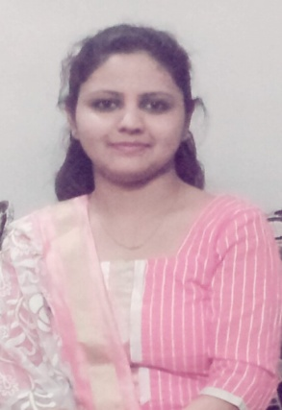
NEHA
E-mail: NEHA.333978@2freemail.com

CAREER OBJECTIVE
Be a part of a team and develop skill & experience within organization. I can play my role responsibly and enhance my teaching skills & knowledge which ultimately leads to a major contribution to organization success.
PERSONAL SUMMERY
A positively motivated, energetic team player who has a strong desire to grow a career in the field of early childhood education. I will always ensure that each child gets as much individual attention as possible, and is committed to raising standards and maximizing children progress. I have a long track record of delivering high quality care and learning opportunities to children aged 5 and above, and am more than willing to assume ultimate responsibility in development of children under her care.
Right now, I am looking to join esteemed school with good facilities, and which believes in nurturing talent and supporting the staff to learn and improve every step of the way.

CAREER CONTOUR
PRESCHOOL TEACHER- JANUARY 2013-PRESENT
AT LITTLE WONDERS, INTERNATIONAL SCHOOL, NASHIK
DUTIES:
- Planning activities based on child’s interest.
- Teaching children through structured play.
- Developing child’s curiosity and knowledge.
- Tidying up the classroom at the end of the lesson.
- Motivating and stimulating child’s learning abilities.
- Building relationship with parents.
- Updating the bulletin boards.
- Pre-paring and arranging pre-class materials.
- Participating in school events.

KEY SKILLS AND COMPETENCIES
Teaching-
- Building relationship with small groups of children.
- Keeping up to date with change in the curriculum and developments in best practice.
- Having patience and self control when dealing with young children
- Good planning and preparation skills.
Personal-
- Ability to relate positively to children and adults.
- Excellent organizational skills.
- Greatly enjoy working with children.
- Able to quickly fit into an established school and work as part of an existing team.

AREAS OF EXPERTIES
- Creative
- Computer savvy
- Classroom Management
- Multitasking
EDUCATONAL AND CREDENTIAL
- 2016-17 Persuade for Masters of Arts(English) Part-1
- 2015 Bachelor in Arts with 61.92%
- 2012 Diploma in Teaching education(D.Ed.) with 82.90%
- 2010 Diploma in Early Childhood Education(ECE) with 82.00%
- 2010 HSC Maharashtra Board with 74.67%
- 2008 SSC Maharashtra Board with 70.46%
PERSONAL DOSSIER
Date of Birth | 05 July 1993
Marital Status | Unmarried
Languages Known | English, Hindi, Urdu
Country | India

DECLARATION
I hereby declare that the above information is true to my belief and knowledge. References will be furnished on request.

