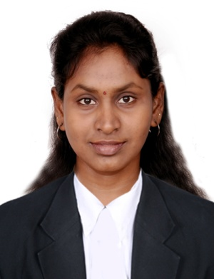
AMUDHA
AMUDHA.333982@2freemail.com

Email: priya.s1225@gmail.com

Profile

I am seeking a challenging position with a Company that is rapidly expanding and offers good advancement potential. I have the determination to attain zenith in every horizon of my career.

Profile Overview

4 Years Professional experience as Accountant and Admin Executive 2 years Experience in customer care. In-depth experience in the entire customer care related activities. An independent worker with a reputation as a resourceful problem-solver who uses her initiative and organizational skills to get the job done. Involving responsibility and working with others as a team member to achieve advancement and growth of the company.

Work Experience

(1st October 2012 - 31st October 2016
Accountant and Admin Executive
Vishnu Cars (Maruti Suzuki)

Job Responsibilities

- Maintain the general ledger, financial records and inter-company accounting.
- Perform period close activities in line with company policies and procedures
- Preparation of various management reporting packs produce error-free accounting reports
- Verify post and reconcile transactions
- Recording & amp; analysis of revenues and expenses
- Liaise with external auditors at year –end
- Handling inbound & outbound calls to communicate with client by their requirements
- Explaining the new availability and specification with client via emails and telephone conversation
- Take care of the entire office procurement which is required for the monthly basis.

01st July 2010 – 31st September 2012
Customer Care Executive
BSA Info media

Job Responsibility
- Manage large amount of Incoming calls
- Generate Sales leads
- Identify and asses customer needs to achieve satisfaction
- Build sustainable relationships of trust through open and interactive communication
- Meet Personal/customer service team sales targets and call handling quotas.
- Handle complaints; provide appropriate solutions and alternative within the time limits follow upto ensure resolution.
- Keep records of customer interactions, process customer accounts and file documents.
- Follow communication procedure, guidelines and policies.
- Take the extra mile to engage customers.

Education

B.S.C | Madras University | 2010 | 65%
(Computer Science)  HSC | MGR H.S.S | 2005 | 67%

Personal Skills

Good verbal and written communication skills, good listener, ability to convince people, willingness to learn, committed to work till satisfaction and will always give my best to whatever I do. Adapt at handing multiple tasks at a time

Technical Skills

Ø Package – PGDCA, Tally Erp9.0

Personal Traits

Ø Can handle Tough situation.

Ø Ability to motivate and excel as a team.

Ø Always willing to learn.

Ø Proactive.

Personal Details

Date of Birth : 24/12/1987
Gender : Female Marital Status : single Nationality : Indian Religion : Hindu
Visa Status : Visit Visa
Valid Visa : 29/01/2017
Languages Known : English, Hindi, Malayalam & Tamil

Declaration

I hereby declare that I am confident of my ability to work in the team as a key player

& the information furnished above is true to the best of my knowledge.

