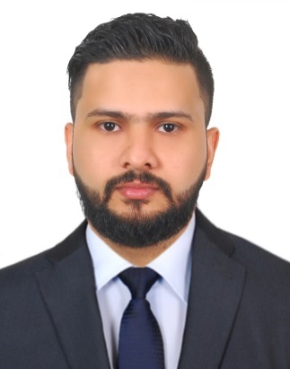
SHABEER
SHABEER.333986@2freemail.com

OBJECTIVES:

To work in a responsible and challenging position of a professional organization where I can utilize my skills, knowledge and my entire personality for the betterment of the organizational and implement better ways and means to achieve the organization goal and objectives.

POSITION DESIRED:
Sales executive, sales marketing, van sales

CAPABILITIES

- Quick at learning new concepts and technologies and putting them to use.
- Excellent Leadership qualities.
- Displaying initiative and independence and can work on own or as a part of a team.
- A Self confident, ambitious & energetic individual, who is consistent,
- Able to work On Deadlines, Extremely Systematic

EMPLOYMENT BACKGROUND

VSION&FASHION DAFZA Dubai:
since:2014 February-2016 may Designation; sales executive
Luxury& premium brands distribute all over uae
Lamborghini ,Baldinini, Bentley etc…
- Explaining to customers the exact way a product or service will be of benefit to them.
- Building Growing sales through existing clients.
- Asking customers what their budget and price range is.
- Negotiating prices and services with customers.
- Identifying the Unique Selling Point of the product or service that you are selling.
- Presenting solutions to key decision makers within targeted accounts.
- Thoroughly researching any customer before you meet up with them.
- Collecting feedback from customers about the product they have bought.
- Making phone calls to customers.

AL JABER OPTICAL L.L.C-(Dubai) Since: April 2011 – December 2013

Designation: Assistant Manger retail store

Job profile:
Explain new product &new style to customer,
solve customer issues- with customer satisfaction and company good will.
merchandising ,division base
teach the new staff about product and customer service
Handling petty cash &daily sale .reporting daily sales report from HEAD OFFICE
Selling luxury &premium brands (Cartier, Fred, Mont blanc, Bvlgari,DolceGabbana etc…)

AL JAZEERA OPTICAL L.L.C Since: January 2008 – February 2011
(Abu Dhabi U.A.E)
Designation: Sales & Technician

THE MIDDLE EAST INTERNATIONAL TRADING L.L.C. Since: September 2005 – December 2007
(Abu Dhabi U.A.E)
Designation: sales& Marketing (Abu Dhabi Market)

Job Profile:

Outlet in-charge, Co-coordinating with distributes. Sales and Accounts, handling customer’s issues Monitoring sales team, daily visits to all outlets U.A.E Procurement & Purchasing of materials Business Development.

TECHNICAL EXPERIENCE:

Driving license (U.A.E)
Diploma in optical technician

EDUCATION:

Secondary School Leaving Certificate - Kerala, India
Higher Secondary School certificate- Kerala, India
Diploma in computer applications
Diploma optical technician

SOFTWARE EXPOSURE:

Orion retail (retail software)
Programmer adding & software installations
MS Office, internet surfing
Auto Cad (2d drawing)
Tally (ERP 9)

LANGUAGES KNOWN:

To Speak: English, Arabic, Hindi, and Malayalam
To Read and Write: English, Arabic and Malayalam

PERSONAL DETAILS:

Date of birth : 05-01-1985
Nationality : Indian
Visa Status : visit visa
DECLARATION
I sincerely state that the above mentioned facts are true to my knowledge and belief.

