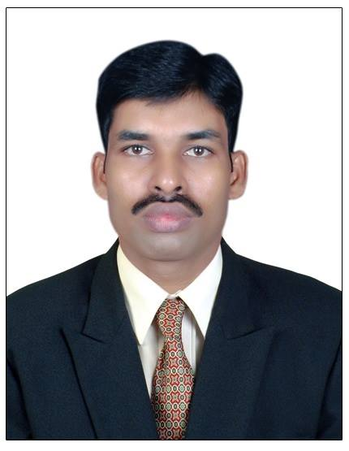
JEETU
JEETU.334021@2freemail.com
ACADEMIC QUALIFICATION:
Passed H.S.C (M.C.V.C) in ELECTRICAL TRADE from Mumbai, Maharashtra Board.

EXPERIENCE:
Designation: Computer Hardware & Networking - Mumbai
- Have worked for TEAMONE INDIA from May 2, 2015 to Nov, 2015 (Computer engineer in (VTRANS INDIAN LTD) Resident Engineer. I have handled Desktop, Networking, Wi-Fi Access Point, Network Printer.
- Second half customer support online.
- Have worked for GLOBO TECH INDIA from Jan 2014 to May 2015(CCTV engineer in installing ) in support IES Trust. Resident Engineer.
- Have worked for ACE TECHNOLOGIES from Dec 2009 to Dec 2011 Customer support in field work.
- Have worked for CYBERSITE INDIA from Nov 2008 to Nov 2009. New desktop installation & software. Trouble shooting in desktop support & upgrade system.
- Have worked for S.G.COMPUTER from MAY 2007 to Nov 2008 Desktop Support Engg.
In installation software, trouble shooting in desktop problem.
- Have worked for ACE TECHNOLOGIES from January 2005 to April 2007 Desktop Support Engg.
Diploma in Hardware & Networking from Jetking Institute - Mumbai
Desktop & networking Support
- Trouble shooting desktop Related issue and trouble shooting of different types of Networking Environment

Skills Acquired in Desktop Support
- Trouble shooting Installing & Configuration of local and network
- Printers, modems, Scanner & Telex Printer etc,
- Installing of Operating system & Application Software
- Setting up of Peer to peer Network with work groups & Cross Crimping
- Installing of OS {Win XP, Win 2000 Professional Server, Win Vista, Server
- 2003 Win 98, Win I7, Win8 , Win10 & Wireless Networking

Job Responsibilities
IT Management
- Providing Hardware & Software Support on various application software & Operating system

Skills Acquired in System Administration
- Remotely Solving the Problem of User by using the {DAME WARE} , Creating LAN Logon
- Creating User ID`s groups Password
- Creating PST files in User Mail box
- Managing User rights, Permission, group member etc
- Unlocking User`s ID & password of Different Domain

Personal Details:
Date of Birth : 12TH OCT, 1981

Languages Known : English, Marathi and Hindi.

Marital Status : Single

Hobbies : Cricket, Chess.

