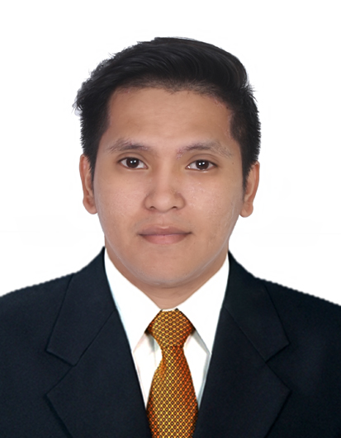
REYNALDO
REYNALDO.334112@2freemail.com

OBJECTIVE:

To be part of a company or institution that will enhance my knowledge and will provide working experience, opportunity for professional development and career growth as a prospective member of the industry.

PROFESSIONAL EXPERIENCE:

LBC Express Inc.
Telecommunication Associate
March 2014 – August 2014

Responsibilities:

- Monitor all connections of LBC branches.
- Report Downtime connection of LBC branches to their respective telco providers
- Provide backup connection for LBC branches.

LBC Express Inc.
I.T Servicedesk Analyst/Technical Support Engineer
August 2014 – December 2016

Responsibilities:

- Support all applications of LBC branches local and international.
- Support hardware issues of LBC branches local and international
- Resets email password through active directory.
- Create accounts through active directory.
- Lan troubleshooting
- Printer troubleshooting
- Install applications and software for back end office.
- Support application issues for back end office.
- Support hardware issues for back end office.
- Monitor CCTV
- Check and Monitor Server room.
- Create tickets.

Nera Philippines
On-the-Job Trainee
Field Engineer
July 2013 – October 2013

Responsibilities:

OJT Trainee

- Prepare all atm, debit, credit cards terminal, pos terminal.
- Troubleshoot all atm, debit, credit cards terminal and pos terminal.
- Deliver all atm, debit, credit cards terminal and pos terminal to clients.
- Replace defective all atm, debit, credit cards terminal and pos terminal.

EDUCATIONAL BACKGROUND/ACHIEVEMENTS:

2007 – 2012 Graduate, B.S. Information Technology, Adamson University, Ermita Manila, Philippines

2004– 2008 Graduate, Academia Institution De San Pedro, San Pedro Laguna, Philippines

1997 – 2003 Graduate, Academia Institution De San Pedro, San Pedro Laguna, Philippines

PROFILE

AGE: 25
BIRTHDAY: August 05, 1991
GENDER: Male
HEIGHT: 5’6
CIVIL STATUS: Single
CITIZENSHIP: Filipino
VISA: Tourist
SKILLS:
- Proficient in basic computer programs: Microsoft software (MS Word and MS Excel)
- Good written and oral communication skills
- Ability to multi-task in a fast-paced environment
- Able to perform task even under pressure

DECLARATION

It is hereby declared that the following information is, with all honest intentions, true and precise.

