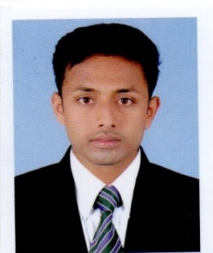
NITHIN
ACCOUNTANT AND AUDITOR

Email : nithin.334119@2freemail.com

Career Objective _____

Highly competent and compassionate Accountant professional having experience working as Accountant on diverse platforms. Multi-skilled and motivated with a dedication for providing the best technical and Administrative support to the Company while eager to contribute my creativity and hard work towards the success of your organization.

Work Experience __

Company Name : Thomas cs &Associates Chartered Accountants

Duration : Oct 2015 – Nov 2016

Designation : Accountant and Auditor ,

Company Profile

Thomas cs &Associates is a leading chartered accountants firm in kerala. Firm manage all Branches of accounts. the firm deals with finalization of company accounts, Trading Companies, statutory Audit of Banks, Tax audit, value added taxes, income tax, Maintaining accounting activities, financial Reports, receipts and deposits, Expenses and others.

Academic Qualification and Certifications __

Master of Commerce, university of Calicut ,kerala,India

Bachelor of Commerce,University of Calicut ,kerala,India

Technical Expertise _

    - Tally
    - Ms office 2007,2009,2010
    - Trade easy
    - Winman
    - Winman Tds
    - Ms excel

Professional summery__________________________________________

- Finalization of company accounts

- Statutory audit of banks

- trading companies

- Tax audit

- Value added tax & income tax

- Maintaining Accounting Activities

- Financial Reports

- Receipts and Expenses Deposits and other

Personal Details _

Date of Birth : 24/08/1992

Visa Status : Visit Visa

Languages : English, Hindi, Malayalam, Tamil

