Danish Danish.334133@2freemail.com

Contact Information  Address  E-mail | 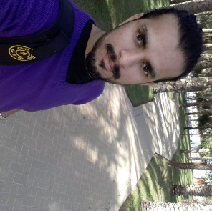 |  | PROJECTS  Data Encryption for Live Cloud Data  (Aug 2016 – Nov 2016)  Successful research on how all the data of the company I work for could be encrypted on all clouds.  Teaching PowerShell  (Feb 2016 – Mar 2016)  Learnt and shared my knowledge of Windows PowerShell through a blog with the URL:  Query Optimization & Indexing  (Jul 2015 – Aug 2015)  Organizing data on Live clouds by implementing indexes on databases and learnt query optimization.  SSIS Packages  (Jun 2016– Aug 2016)  Made a vital package for the VP development of my company which is now used as benchmark for SSIS Packages in the team.  ACHIEVEMENTS  My First Website  (2002)  Eager to become a software engineer one day, I complete my first website when I was 11, URL:  INTERNSHIP  Teaching young orphan children in a small Pakistan city named Sargodha – (Jun 2012-Jul 2012)  HOBBIES & INTERESTS  I love playing and watching sports with Football is my favorite sport.  My favorite time of the day is the time spent in Gym.

PERSONAL STATEMENT
Highly Motivated person, always obsessed with being better than the day before.

PROFESSIONAL SKILLS

SQL Server
SSIS
Windows Powershell
C++
Photoshop
HTML
JAVA
C#
JAVASCRIPT
JQuery
XML
C
Objective C

EXPERIENCE

Software Engineer in New York based company “CureMD” – (Jun 2015-Present)

EDUCATION

Bachelors In COMPUTER

SCIENCE| (2010 – 2015)

FAST-NU Lahore, Pakistan

A Levels | (2008 – 2010)

SICAS Lahore, Pakistan

