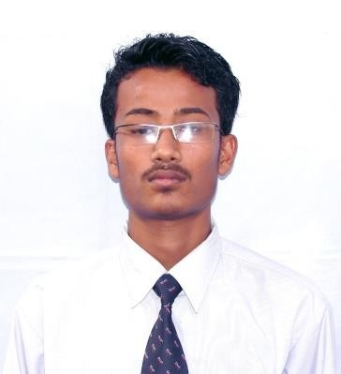Curriculum vitae
PRAKASH
PRAKASH.334139@2freemail.com

Objectives:-
I always like to work in challenging environment to improve my professional skill. To further and abilities in an area of competition and give maximum services and responsible role in a reputed organization, where my skills could be best utilized and where I can grow professionally. To play an important part for the development and prosperity of your renowned organization with the dedication and perseverance and achieve the pinnacle of success both for the organization and me.

Academic Details:-

S.N | BOARD | INSTITUTE | DIVISION | YEAR
1 | S.L.C | Shree Dhumabraha Sec. School | 1st | 2009
2 | HSEB +2 | Brilliant Edu. HS School | 2nd | 2011

Work Experience Details:-

- Four Year experience at Extreme Fitness and Dance Centre as a Teacher, ( Ladies Fitness, Dance ),( Nepal ).
- Two Year Experience at Mars Magic Beauty Home As a Fitness & Dance Instructor, ( Nepal ).
- Five year Experience at Happy Feet Montessori & Teacher’s Training Centre, ( Nepal ).
- Six Months Experience at Global Peace Association as a Volunteer Coordinator, ( Nepal ).
- Three year experience at Deepak Gautam& Co. Pvt.Ltd ( Mercedes–Benz- Nepal ) as a Sales and marketing Supervisor, ( Nepal ).
- Work at Gulf Coasts Co.LLC ( UAE ) at Call Center Sales Department since 2015/06/05.
- 4 years work experience in Media ( Photography& cinematography ) , ( Nepal, UAE).
Training Details:-

S.N | INSTITUTE | LOACTION | Course Details | Duration
1 | Friendship Training Institute | Chabahil,KTM | Diploma In Adv. Basic Computer | 3 Months
2 | Friendship Training Institute | Chabahil,KTM | Diploma in Hardware, Software & Networking | 6 months
3 | Redstone IT Academy | Sundhara,KTM | MCITP ( Microsoft Certified IT Professional ) | 6 Months

Special skills, knowledge :-

Hard worker, quick learner, self-starter, good communicator, Active team player, Time management, interpersonal skills, have knowledge of recruitment, selection, training as well as performance appraisal process, motivate the employees for the best outcomes as well as to be as best leader.

Personal Details:-

First Name : PRAKASH
Last Name : THAPA
Date of Birth : 22-04-1991
Marital Status : Un-Married
Nationality : Nepali
Religion : Hindu
Passport Issue : 11-05-2014
Passport Expire : 10-05-2024
Language known : Nepali, Hindi & English

DECLARATION :-

I hereby declare that all the above-mentioned details are true and correct to the best of my knowledge & belief.

