Curriculum Vitae

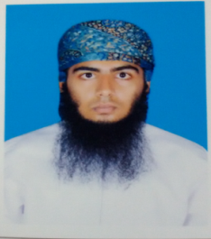
Personal Information:
Name : Dhiyab
Dhiyab.334153@2freemail.com

Education:
- Bachelor Degree in Internet and E-security from Al-Musanna College of Technology – (GPA: 3.16 out of 4).
- Training certificate of IT support.
- Two training certificates of Cisco Certified Network Associate.
- Certificate in computer application with grade A.
- Certificate in English language with grade A.
- Certificate of Participation in “TechFest2015” of national level technical extravaganza in IT field.
- Certificate of good conduct issued by ministry of education.
- General Diploma of Higher School.
- Driving license (7 years old).
Key Qualification:
- Advanced Knowledge and practice to create websites.
- Advanced Knowledge and practice to use java, php, c# and html, linux OS and oracle SQL programming, and word press with studies background of android, windows server 2008 and 2012.
- Advanced Knowledge and practice to create/ establish different types of networks and ensure their security.
- Advanced Knowledge and practice of troubleshooting and system maintenance.
- CCTV camera installation.
- Willing to maintain professional and technical knowledge by attending educational workshops, reviewing professional publication, establishing personal networks, and participating in professional societies.
- Knowledge of administration and management.
- Knowledge of planning reviewing reporting and follow-up the documents.
- Ability to work in a dynamically changing environments as well as hard working and eager to learn.
- Strong ethics and high motivation standers.
Experience:
IT support (2 months) in Khatib & Alami and Partners company.
Software Practice& Background:
- Microsoft windows application like (Word, Excel, Power point, outlook, Project and Access).
- Adobe master collection like (Dreamweaver, flash professional and Photoshop).
- Ability to use Packet tracer, Visual studio, Notepad, and my SQL database, with studies background of oracle database.
Languages: Arabic “Mother Tongue”, English “good”, Balushi “fluent” and Urdu “intermediate”.

