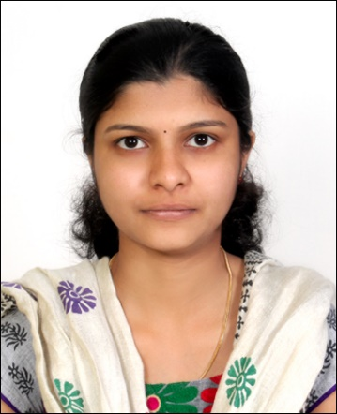
JINU
Email: jinu.334167@2freemail.com

Summary

- Dedicated, Resourceful and goal-driven professional educator with a solid commitment to the overall development of every student.
- An accommodating and versatile individual with the talent to develop inspiring hands-on lessens that will capture a child’s imagination and breed success.
- Aptitude to remain flexible, ensuring that every child’s learning styles and abilities are address.
- Superior interpersonal and communication skills to foster meaningful relationship with students, staff and parents.

Highlights

- Creative lesson planning
- Academic performance evaluations
- Resource Management
- Standardized testing
- Common core knowledge
- Compute proficiency
- Conflict resolution skill
- Technology integration

Experience
Physics teacher Dec. 2013 to Present
Little Flower public school, Kottayam, Kerala, India.

Instruct secondary school curriculum, designing and developing programs to meet the academic, intellectual and social needs of students.

Conduct classroom and outdoor activities with students based on differentiated learning needs to ensure all students are learning at full potential.
Organize parent- teacher conferences to maximize student learning opportunities and develop forward- thinking plans to correct ongoing issues.
Attended a variety of professional development workshops centered on learning goals, classroom management and engaging learning activities.

Education

Bachelor of Education (2013); Major: Physical Sciences Education, Elective: Guidance and Counseling, Mahatma Gandhi University, India.
Master of Science (2012) Major: Physics; Mahatma Gandhi University, India.
Bachelor of Science (2010) Major: Physics; Mahatma Gandhi University, India.

Computer Qualification
Digital teaching methods
Various educational software and applications
Computer operations and languages

Personal Details

Date of birth 02 March 1989
Marital status Married
IELTS 7 Overall
Languages

Malayalam Mother Tongue
English Fluent
Hindi Basic

References

References available upon request

