CURRICULUM VITAE

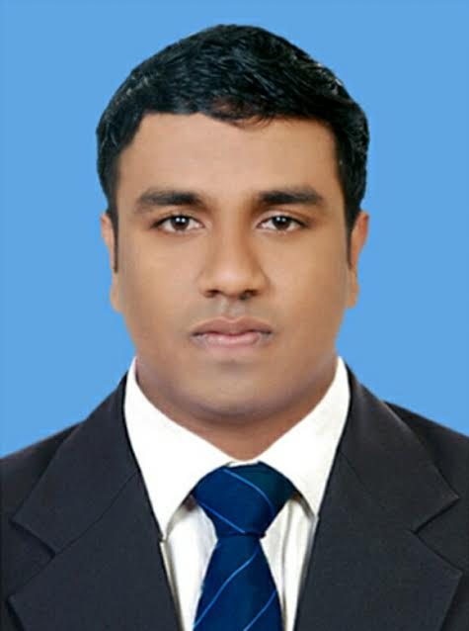
SHAROOKH

Email: SHAROOKH.334202@2freemail.com

Objective
To obtain a position where I can maximize my management skills, quality assurance and abilities in an organization, which offers high career growth, while being resourceful, innovative, and flexible to the company environment and explore myself to different and extreme limits.

Work experience
Innovative Solutions | April 2014— November 2016
Office Assistant

- Planned and coordinated logistics and material for board meetings, committee meetings and staff events
- Managed the internal and external mail functions and provided telephone support
- Scheduled client appointment maintained up to date confidential client files.
- Helped distribute employee notices and mail around the office
- Assisted with event planning, including associated travel and logistical arrangements
- Document Controlling (customer information form C.I.F)
- Tariff sheet and dongle managing
- Inventory controlling ( Sims ,Dongle, Tariff sheet)
Achievement
- Leadership Award BA Fest
- Participated and team leader of Business outfit in KMM College arts and science
- Coordinator of BA Fest – Kerala-India
- Member of cultural activities in college
- Award Winner a study on the Employee grievances and welfare measures.

Strength
- Honest ,Integrity, Trust, Self Confidence, Patience, Interpersonal skills
- Leadership skills, Team Work
- Good listener, self motivated, quick learner

Linguistic Abilities

- English
- Hindi
- Malayalam

Personal Abilities
- Excellent planning and organizational skills
- Problem solving skills
- Ability to organize & prioritize workload within any setting
- Ability to communicate effectively in English , both orally and in writing
- Ability to take responsibility and function under minimal supervision

Education
SSLC March 2006— March 2007

Board of Kerala Examination

Higher Secondary Education June 2007 — March 2009

Board of Secondary Education

Degree in Bachelor of Arts May 2011 — March 2014
Mahatma Gandhi University
KMM College of Arts and Science

Tally.ERP 9 ( Tally Institute of Bangalore ) June 2015 __ October 2015

Computer skills
Microsoft Word, Excel, PowerPoint, Outlook Express, Microsoft Windows XP and Microsoft Office XP Professional
(Certified from tally Institute Bangalore)

Personal Details

Gender : Male

Date of Birth : 03-07-1991

Place of Birth : Ernakulam,Aluva

Nationality : Indian

Marital status : Single

Languages known : English, Hindi, Malayalam,

Visa status : Visit Visa (Expire on 20-03-2017)

References.

Reference shall be furnished upon request

Declaration

I hereby declare that the information furnished above is true to the best of my knowledge. I am also

confident of my ability to work in a team.

Thomas Anderson 2

