ROHINI  E-mail : rohini.334226@2freemail.com |  |  | 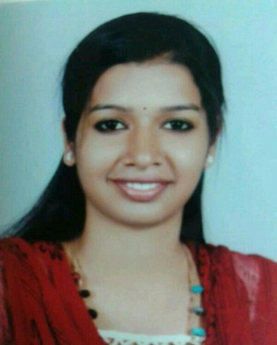
Profile in brief
An enthusiastic person who likes to take up responsibilities and fulfil them. Well trained to co-ordinate, organize &execute work among groups.Self-motivated, good in decision making, critical thinking, organizing and planning.

Career Objective
Obtain a position as a School Teacher that will utilize my strong dedication to children’s development and to their educational needs.

Education – Courses
MBA,TRAVEL AND TOURISM (KITTS) University of Kerala, India |  | 2009-2011
BBA (UIT), University of Kerala, India |  | 2007-2009

Jobs under gone

Worked as Teacher (Travel & Tourism, social studies ) at Vaavu Atoll School, Fulidhu, Maldives under Ministry of Education- Maldives. Teaching Cambridge
IGCSE Syllabus.

Worked as Centre CEO for Cradle to Crayons Pre School and The Wonder years Pre School Trivandrum

Worked as customer service agent for BHADRA INTERNATIONAL INDIA LTD, which provides ground handling services at seven major airports in India.

- Experienced in Passenger & baggage services including Check-in, Baggage tracing and Reconciliation and associated terminal activities.

- Conversant with handling of delayed Flights.

- Familiar with meet and greet functions with focus on passengers needing special assistance.

- Obtained training & experience in passenger check-in, baggage reconciliation, special assistance and other passenger related activities.

- Done AVSEC training and DGR training (basic), imparted by BHADRA.

- Worked as volunteer for the International Film Festival of Kerala 2010. Worked as volunteer for the International Film Festival of Kerala 2011. Worked as volunteer and anchor for the Kerala State Film Awards.(while pursuing MBA)

- Worked as front office trainee in Udaya SamudraLeisure Beach Hotel, Kovalam from October 2010-December 2010. Worked as volunteer for the South India Hotelsand Restaurants Convention (SIHRA).(while Pursuing MBA)

- Worked as part-time event management volunteer with 141 Sercon Event Management company.

Projects Undertaken
- Successfully completed a project study on The Effect of Advertisements provided By Venpakal Advertisers.
- Successfully done an organization study on Udaya Samudra Leisure Beach Hotel, Kovalam.
- Successfully completed a project study on UNWTO`s Sustainable Tourismfor Eliminating Poverty -‘STEP’

Achievements
- Obtained training & experience in passenger check-in, baggage reconciliation, special assistance and other passenger related activities.
- Done AVSEC training and DGR training (basic), imparted by BHADRA.
- Awarded with `WELL DONE` certificates from SIHRA (South Indian hotels and restaurants association) for organizing and volunteering their annual convention.
- Received certificates of appreciation for participating and winning various management events and games.

Computer knowledge
- Proficient in MS Office (Word, Excel & PowerPoint), Internet and E-mail applications.

Personal Details
Nationality | : | Indian
Date of Birth | : | 07 AUG 1988
Sex  Marital Status | :  :  : | Female  Married
Languages known | : | English, Malayalam, Hindi & Tamil

