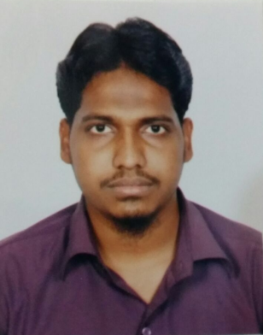
Ashfaaqh
IT Infrastructure, Network& System Admin
Leverage 6 years of experience spanning IT infrastructure, communication and network management, system operations, and disaster recovery
Ashfaaqh.334230@2freemail.com

IT Infrastructure, Network & System Administration Professional  Al-Hassan Group of Companies, Muscat, Oman as IT Administrator  Domain Expertise Lies in: Construction, Engineering, Oil and Gas and Pipeline, Cargo and IT | Profile Summary
- Skilled in managing the design, installation, upgradation, maintenance, and troubleshooting of multiple Cisco ASAs and multiple Demilitarized Zones (DMZs) per context in a highly available/redundant configuration
- Administered firewall performance tuning, installing and configuring multiple Demilitarized Zones (DMZs), configuring, troubleshooting wired and wireless network problems, checking firewall logs and activity
- Enriched experience in managing Windows Server and Vmware
- Conducted performance and stress testing of the network and security components to ensure effective information systems security
- Prepared disaster recovery plans for the network and security devices; interfaced with vendors for network and security products
- Ensured that IT systems, applications, and communication equipment within the organization were managed and maintained in accordance with documented processes, procedures, guidelines, and instructions
- Handled the design, installation, commissioning, maintenance, management, modification, troubleshooting of Process Control Domain (PCD) Security Systems and Networks while ensuring that Process Control Domain (PCD) assets perform as per business expectations
- Maintained integrity, availability, and confidentiality targets as defined via a risk-based approach
- Supervised manpower and handled segregation of duties along with authorization and implementation of changes in the Process Control Domain (PCD)

Career Timeline
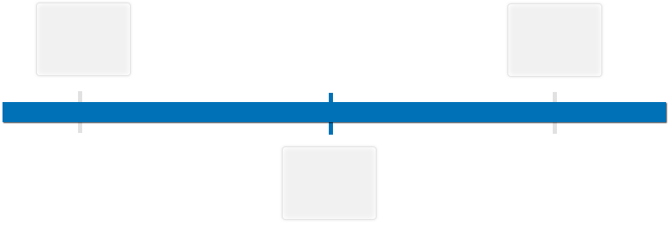
Leaap International as Desktop Support Engineer
iOPEX Technologies, Chennai, India as Desktop Support Engineer
Al-Hassan Group of Companies, Muscat, Oman as IT Administrator
Since 2013
2010-2013
2010-2010

Core Competencies |  | IT Infrastructure Management IT Network  Troubleshooting Windows Server and Virtualization  Firewall Performance Security Systems and Networks
Organizational Experience

Since Sep’13 with Al-Hassan Group of Companies, Muscat, Oman as IT Administrator

Key Result Areas:
- Planning, organizing, and ensuring quality assurance of IT security within the Process Control Domain (PCD); delegated responsibility to the Process Control Domain (PCD) Incident Owner in the event of a Process Control Domain (PCD) IT security incident
- Monitoring network performance including maintenance, upgrades, and back-up/recovery responsibilities including software (operating systems, applications, and data) and hardware (process control domain equipment and network equipment (e.g. switch, router, and firewall)
- Leading the Network and Infrastructure Section team comprising of Security, Local Area Network (LAN), Wireless and Data Centre personnel in implementing the organization’s IT standards, framework and strategy
- Involved in configuring and managing:
- Windows 2008 r2 server environment with services ADDS, DNS & DHCP
- HP procurve switches
- Sonciwall NSA E5500 series firewalls
- Access rules, App control, content filtering, routing and NAT
- VMware Vsphere virtual servers
- Mdaemon mail server
- Site-to-site VPN tunnels, IPsec VPN in Sonciwall NSA and TZ series firewall for remote location connectivity
- Sonicwall GMS for centralized management of remote sonicwalls and backing up and reviewing of logs
- Wireless infrastructure with Meru IDM, Meru controller and meru wireless AP devices for implementing BYOD
- Buffalo NAS storage devices and managing the data backups
- Administering Kaspersky Anti-virus server and configuring policies, auto-upates,auto-scanning the client PCs
- Maintaining assets, troubleshooting,managing Licenses through Manage Engine Desktop central tools and troubleshooting L2 issues

Accomplishments:
- Played a vital role in ensuring the implementation and configuration of:
- Meru wireless architecture which includes Meru IDM and Meru Controller device along with Meru Access points which is useful for Guest registration and Bar code scanning,which inturn helped in automation of 80% of manual tasks
- Site-to-site VPN connectivity for communication between Head office and branch office using sonicwall TZ series and NSA E5500 firewall
- Web filtering and providing time based internet access for all branches
- Storage/backup for branch office using Buffalo terastation TS 5400 NAS box,configured with incremental backups on daily basis and authenticates the user through Active Directory server
- Manage Engine desktop central tool for Asset management, Software deployment, Patch deployment,support through Remote control and report generation of Active directory users and computers
- Instrumental in deployingSonicwall UTM devices for centralized accessing of firewalls and for logs and reports generation which resulted in optimizing the bandwidth usage based on the reports
- Had been a major part of ISO and Microsoft IT auditing

Nov’10 – Aug’13 with iOPEX Technologies, Chennai, India

Growth Path:
Jul’12 – Aug’13: Network Administrator
Nov’10 – Jul’12: Desktop Support Engineer

Key Result Areas:
As Desktop Support Engineer
- Ensured installation of all OS platforms like win7, linux& application software and Lotus notes
- Managed creation &deletion mail IDs and Windows Active Directory Server 2008
- Supervisednetwork and internet traffic and maintained inventories of devices
- Managed Anti-Virus server, assets and inventories

As Network Administrator
- Involved in managing Cisco Routers 3845 series
- Formulatedaccess rules and NAT rules in Sonicwall NSA- 2400
- Handled Cisco Chassis 6509 series
- Ensured configuration of VLANs, assigning Switch Ports to corresponding VLAN
- Maintained MAC-based access list in wireless router, VPN and MPLS links

Sep’10- Nov’10 with Leaap International, Chennai as Desktop Support Engineer

Technical Skills-Set
- Network essential
- Configuring Firewalls like Sonicwall,ASA firewalls
- Creating and managing standard and extended Access- lists, NAT rules
- Creating and assigning VLANs in switch
- Configuring and managing VTP,STP,RSTP,PVST+
- Configuring routing protocols like RIP,IGRP,OSPF, EIGRP
- Configuring and managing IPsec, SSL VPNs
- Configuring Wi-Fi routers
- MCSA
- Managing and maintaining a Microsoft Windows 2003, 2008 and 2012Server Environment like ADS and DNS.
- Implementing and maintaining a Microsoft 2003, 2008 and 2012 Network Infra Structure and services like DHCP, RRAS, VPN and NAT
- Installing Configuring and Administrating, Microsoft Window XP Professional, windows 7 and windows 8 environment
- CCNA Security:
- Configuration of AAA RADIUS and TACACS+ in cisco switches and routers.
- Firewall technology and statefull inspection
- Cisco ASA firewall
- Intrusion Prevention System(IPS) on cisco devices
- IPv6 IP tunneling
- IPsec and SSL VPN configuration on cisco devices
- Port security on Cisco switches
- Zone based firewall implementation

Academic Details  Professional Qualifications  Technical Qualifications |  | - Pursued Graduate Degree in Computer Applications (B.C.A) from Annamalai University in May 2013  - Pursued Diploma in Electronics Communication Engineering (ECE) April ’10 with 1stclass distinction 90% through V. Rama Krishna polytechnic College (DOTE)  - Soft Logic Certified System Administrator (MCSA) fromSoft Logic Academy Pvt. Ltd., Chennai in 2010  - CCNA Security from IIHT, Vadapalani, Chennai in in 2016  - Pursued CCNA from IIHT, Vadapalani, Chennai in 2016  - Manage Engine Certified Product Associate (MECPA) in 2016  - Advantage Pro Certified Hardware & Networking with A-grade through Advantage Pro Chennai in 2009  - Cisco Certified Network Associate  - Manage Engine Certified Product Associate (MECPA)  Thinker  Planner  Communicator  Collaborator
Skill Set |  | Change Agent

