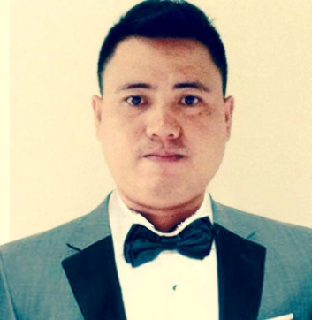
Bryn
Bryn.334329@2freemail.com

CAREER OBJECTIVE
To work in a creative and challenging where I could constantly learn and gain expertise in the hotel& restaurant industry and develop competency and enhance my skills in the hospitality world, to accomplish progressive goals through my sincere results oriented efforts by delivering solutions to the problem and achieving targets set by the management.

WORK EXPERIENCE:
WORK EXPERIENCE
Waiter: Hyatt Hotel and Casino: January 2013 – March 2015

- Greet customers and seat them according to their preferences
- Offer welcome drinks and beverages
- Fill water glasses and refill beverages
- Offer appetizers and alcoholic drinks
- Take orders and provide information about menu items
- Suggest menu items when requested by the customer
- Relay patrons’ orders to the kitchen

Steward: Hyatt Hotel & Casino Manila – September 2011 up to November 2012

• Assisted in the cleaning and organizing of the food and beverage outlets
• Sorted dirty ware so that it can be put to the dish or pot machine appropriately
• Washed all ware and replaced in storage areas
• Kept dish machine accurately cleaned and filled with water
• Operated burnishing machine to ensure proper finish on silverware
• De-tarnished and polished silver for good appearance
• Cleaned kettles, tilted skillets, pots and pans quickly so cooks can do their work efficiently
• Performed other job related duties as assigned by kitchen manager

SALES CLERK :CANDIES APPAREL – SM CENTERPOINT, MANILA, -ffffFFFFffebPHILIPPINES:AUGD2DDEDEDECEMBER 2013

- Direct customers to different aisle or shelf that holds their choice of products.
- Provide customers with pricing information.
- Assist customers in making purchase decisions and make sure the payment procedures are expedited.
- Stock items on shelves in accordance to the instructions provided by the sales manager.
- Attach price tags to each item and make sure that they reflect updated price.
- Provide customer with information on current promotion and sales.

EDUCATION

Bachelor of Science in Maritime Transportation (BSMT)
- Philippines Maritime Institute
Quezon City, Philippines
2007 -2010

PERSONAL PROFILE
Age: 27
Date of Birth: Feb 17, 1989
Nationality: Filipino
Civil Status: Single
Religion: Roman Catholic

OTHER SKILLS
- Knowledgeable in Microsoft Word and Excel

I hereby certify that the information given in this document is true and correct to the best of knowledge and belief.

