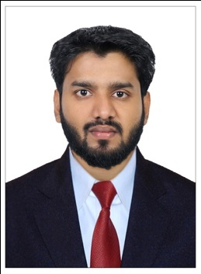
MUHAMMED
MUHAMMED.334431@2freemail.com
Administration / Accounting

Profile Summary

A reliable, dynamic and straightforward Admin/accounting professional who is committed to providing a quality, bespoke service that is second to none. Well experienced in understanding the needs and requirements of people and has a track record of working to exceed these wherever possible. I am always positive and proactive in finding solutions to problems. My strengths include the desire to help customers and her ability to drive customer loyalty and retention.

KEY SKILLS AND COMPETENCIES
Administration / Accountant
- Coordinate office activities and operations to secure efficiency and compliance to company policies
- Supervise administrative staff and divide responsibilities to ensure performance
- Manage agendas/travel arrangements/appointments etc. for the upper management
- Manage phone calls and correspondence (e-mail, letters, packages etc.)
- Support budgeting and bookkeeping procedures
- Create and update records and databases with personnel, financial and other data
- Track stocks of office supplies and place orders when necessary
- Submit timely reports and prepare presentations/proposals as assigned
- Assist colleagues whenever necessary
- Above average ability to achieve goals.
Personal
- Possessing a clear voice and a commanding tone.
- Able to get along with and form close working relationships with people from the all parts of the world
- Numerate and computer literate.
- Willing to seek guidance and advice when necessary.
- Always championing equality and diversity.

Experience

Administration/ Accounting
atPM Foundation,
Cochin, India. (March 2016– December 2016).

Responsibilities
- Drafting professional mails.
- Responding quickly to situations.
- Taking inbound calls from clients.
- Managing, manipulating and inputting data to spread sheets.
- Carrying out a variety of administrative tasks.
- Complying with the Data Protection at all times.
- Dealing with the accounts.

Sales Executive
atSara Group of companies
Cochin, India. (March 2016– December 2016).

Responsibilities

- Maintain and develop good relationship with customers through personal contact or meetings or via telephone etc.
- Must act as a bridge between the company and its current market and future markets.
- Display efficiency in gathering market and customer info to enable negotiations regarding variations in prices, delivery and customer specifications to their managers.
- Help management in forthcoming products and discuss on special promotions.
- Review their own performance and aim at exceeding their targets.
- Record sales and order information and report the same to the sales department.
- Provide accurate feedback on future buying trends to their respective employers.

Education

- B.com Computer Application:

(Mahatma Gandhi University, India)

- Commerce from the Board of Higher Secondary Education Kerala.(March-2013)

Computer knowledge

- Tally Certified
- Office Applications.

Languages known
English, Malayalam,Hindi and Tamil
Personal Profile
)
Date of Birth : 28th may, 1994.
Nationality : Indian
Marital Status : single

References: Available on request

