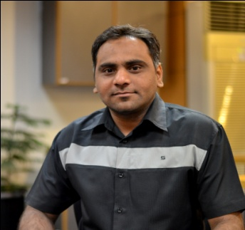

MUHAMMAD
Muhammad.334440@2freemail.com
Objective | Seeking a challenging career oriented position in a dynamic organization, which provides an opportunity for achievement. That allows me to utilize my skills, knowledge and experience and let me to testify my competency and confidence with greater responsibility |  |  | Work Experience
Oracle computers
April 2011 to october 2016

HR –Recruitment officer
- Fulfill the vacant positions within the time line with right candidates.
- Select the correct sourcing method for the recruitment and accordingly post the job
- Receive all the job applications, sort and classify based on each profession and store in database for retrieval as and when required.
- Coordinate for Walk-in Interviews when required
- Updating vacancy and applicant status within the recruitment procedure, organizing interviews and producing interview schedules
- Implementation of recruitment objectives, policies.
- Daily activity Report to HOD
(Allah Yaar Steel Works)
May 2007 to December 2008
Office Admin
- Oversees and administers the day-to-day activities of the office.
- Develops policies, procedures, and systems which ensure productive and efficient office operation.
- Assists in the coordination, supervision, and completion of special projects.
- Coordinates the disposition and resolution of individual problems and disputes involving faculty, staff, as they arise.
- Provides assistance in the understanding and interpretation policies and procedures, as appropriate, and ensures that office operations are in compliance with policy provisions and standards.
INTERNSHIP (NBP)
March 2008 to june 2008
internship in National Bank of Pakistan after completed B.com, during internship program i learn about below Department / section
- General Banking dept.
1- inquiry 2- Deposit 3- Bills 4-Accounts
- Credit Dept.
- Credit Administration (CAD) 2- credit processing
3-Housing Loan
- Foreign Exchange dept.
1- F.C.A/ Cs/ Remittance 2- Export/import section
3- Bills of exchange
- Administration dept.
1-Reconciliation 2- staff loan 3- Compliance welfare

Education | MBA  MASTER IN BUSINESS ADMINISTRATION  HR & MARKETING  Superior University Lahore  Graduation:  Punjab University (B.Com) |  | 2010  2007
Skills | Professional Skills  - Confident and deal with issues directly.  - Good Presentation & Communication Skills  - Good at Public dealing & HR Management  - Technical Report and Business Letter Writing  Computer Skills  - Win 2000/XP/Vista / 7/ 8.1, Microsoft Office  - Graphics : inpage, CorelDraw, Adobe Photoshop
Personal Info | Date of Birth  Marital Status  Nationality | 20-08-1984  Single  Pakistani
VISA Detail | Visa expiry  Visa type | 30 Jan 2017  Tourist
Languages | - Urdu  - English
Reference | Will be furnished on demand

