ASHA  E Mail Id : ASHA.334450@2freemail.com | 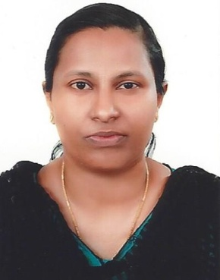

Career Objective
To utilize my skills in a professional environment for the mutual benefit of myself and the organization and to take every assignment as a challenge, complete it in a professional manner while working hard with the team and try to be an asset to the company.
Professional Experience
Customer Care Executive
Company : S S Hyundai Mavelikara, Kerala-India.
Period : 1 year, from July 2015to August 2016
Duties and Responsibilities
- Keep records of customer interaction and transactions recording details of inquiries, complaints and comments, as well as actions taken.
- Ensure that appropriate actions were taken on customer’s request.
- Refer unresolved customers grievance or special requests to designated departments of further investigation.
- Site Meeting with clients.
- Customer Services, Relationship Management and Negotiations.
- Proven Leadership capabilities with strong supervisory and relationship management skills.
- Preparation of monthly reports for projects.

Aircraft Technician Trainee
Period : 6 months, from January to July 2011
Aircrafts handled : Ht2 Aircraft, Cessna Aircraft, Heavy Aircraft (Lear jet)
Duties and Responsibilities:
- To Repair, inspect & maintain the structural elements of the above mentioned Aircrafts.
- Marshalling, wheel chocking, fuelling & refuelling of aircrafts at ground.
- Routine inspection and document inspection of the aircrafts and make log book regarding the inspections.
- Engine Run-up, Fault rectification of HT2, Cessna and Lear jet.
- Wheel alignment and wheel balancing of aircraft tyres and thus ensure safety.
- Overnight and Daily Inspection of the aircrafts.
- Removal, Installation and fault rectification of flaps, DC battery system, etc.
- Elevator, aileron and rudder control rigging of the aircrafts.
- 100hrs or monthly inspection for the above mentioned aircraft.
- Functional check on Hydraulic system and make the aircraft efficient in landing and takeoff.
- Cleaning and Polishing of aircrafts.

Professional Qualifications

Course : Aircraft Maintenance Engineering
Institute : Southern College Of Engineering and Technology
Board : Director General of Civil Aviation, Government of India.
Year of completion : 2011
Percentage obtained : 81%

Course : OFFICE SECRETARY/PRO Training program
Institute : Data tech Mavelikara, Kerala-India.
Board : Accountants Service Society.
Year of Completion : 2011
Percentage obtained : 97%

Course : AutoCAD 2D and 3D in civil
Institute : Bghud Mavelikara, Kerala-India.
Board : Kerala Board
Year of Completion : 2016
Percentage obtained : 85%

Competencies
- Organizing Skills
- Willingness to learn new concepts
- Good leadership qualities and interpersonal skills
- Highly motivated.
- Systematic and hardworking
- A good team player with positive attitude and enjoy motivating & appreciating other
Additional Skills

- MS-Office package
- Photoshop
- AutoCAD:2D&3D

Personal Details

Date of Birth : 23 January1990
Nationality : Indian
Sex : Female
Marital Status : Married
Languages Known : English, Hindi, Tamil and Malayalam
Driving licence : Valid Indian license for car
Visa Status : Visit Visa, expire on 25th March 2017.

