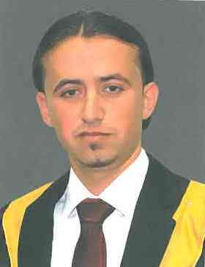
CURRICLUM VITAE

SALEH
Address :- Jordanian
E-Mail : saleh.334454@2freemail.com
OBJECTIVE:-

To work in growing company where I can take on challenge and complete and my given responsibilities by using experience, my skill and pre-experience. So as to make a good reputation and career .
I am seeking for joining a challenge job in a progressive organization witch I can be best utilized according to my abilities performance efficiency .

PERSONAL DATA:-
Nationality : Jordanian
Name : Saleh
Marital Status : Single
Date of Birth : 11/04/1991
Gender : Male

ACADEMIC QUALIFICATION:-

- BSc : Hussein Bin Talal University- Faculty of Arts – BSc. In English Literature – 2014 – Fair

- ICL : INTERNATIONAL COLLEGE IN LONDON (English Studies) : Professional Training Diploma .

WORK EXPERIENCE:-

- ADAM AND HAWA School – Two years : I worked as a teacher for five classes and breeders seventh class in a private school (Adam and Eve) for two years and I have the experience .
- Marketing (sale and purchase)- One year : I worked as a sales person such as providing goods to customers shop is name: green saloon sweets .
- Hotel receptionist – 6 months : I worked as a supervisor in a hotel for six months .
- Data Entry– 6 months : I worked in office as input data by Computer for six months .

Personal Skills:
- I have the ability to work good individually and in a group.
- I have the ability to learn new skills in short time.
- Flexable and have ability to work under pressure.
- I Have:
1-Project Management Skills.
2-Strategic planning skills.
3-Good interpersonal skills.
4-Time Management skills
5-Good communications skill

Course and Skill:

- ICL : INTERNATIONAL COLLEGE IN LONDON (English Studies) : Professional Training Diploma .
- Computer skills ( Word, Excel, windows, Access, Power point, internet ) .

Computer skills:
- I have very good experience in network.
- Very good in using office programs (Windows & Word & Excel & Access & PowerPoint& Internet).
- How to use the above applications and program.

Languages:

- Arabic – Excellent : Mother tongue Fluently of Arabic .
- English – Reading, writing, conversation: Fluently command of English (written & spoken).

