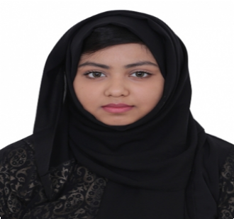
Tarannum
Tarannum.334493@2freemail.com

Work experience

Home Tutor 2012 — Present
Tutor
From KG to Grade 8

Gulf Food 2015
Promoting Capri Sun

Casio Calculator 2015
Promoting Casio Calculator

Alokozay 2015
Promoting Alokozay Tea

TESOL Arabia 2015
Voluntary Work

Qualifications
Successful Completion of IELTS with 6.0 bands.
Successful Completion of SAT (Math only) with overall score of 500.

Education

High School September 2012 — May 2015
Dubai Modern Education School
Diploma with average of 94.8% (American Curriculum)

International Foundation Programme September 2015 — April 2016
Middlesex University Dubai

Interests

Reading (Non-fiction, Realistic, Horror and Mystery Socializing
Computing Cooking Baking
Sketching and painting and crafting Solving puzzles
Sports (Badminton)

Skills

Excellent communication skills (English, Urdu, Hindi and Bangla). Easily adapt in team environment as well independently.
Fluent speaking in English, Urdu, Hindi and Bangla. Fluent writing in English and Bangla.
Leadership qualities.
Computing skills (MS Office, Typing, Internet Browsing and Blogging). Time and project management.
Creative thinking style. Excellent multi-tasking skills Good teamwork skills

References
References available upon request.

Personal Details
Nationality: Bangladeshi
Date of Birth: 7 February 1997 Marital Status: Single
Gender: Female Religion: Islam

