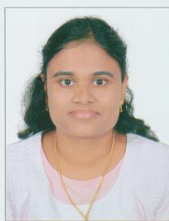
CARRICULUM VITAE

SINDHU
HAAD LICENCE NO. AS REGISTERED NURSE
E-mail: SINDHU.334497@2freemail.com

Personal details
Name : Mrs. Sindhu
Date of Birth : 21.05.1979
Nationality : Indian
Sex : Female
Marital Status : Married

Educational Qualification

Diploma in Nursing and Midwifery (period 1997-2000), The Kerala Nurses and Midwives Council
Pre-Degree from Kerala University (year of passing 1996, Two year course)
S.S.L.C from Kerala Board of Secondary Education in 1994
Work Experience
At present working in Bright & White Dental Centre, Abu Dhabi as a Dental Assistant Nurse till today.
From July 2006 to January 2016 in Al Ahali Medical Centre, Abu Dhabi as a Dental Assistant Nurse
From March 2003 to December 2005 in Sree Venkateswara Hospital, Chertala, Kerala, India as Staff Nurse in their Pediatric Department
From January 2000 to February 2003 in S.H. Hospital, Alapuzha, Kerala, India as Staff Nurse in their Pediatric, New Born ICU, Surgical and Casualty Department – six months each
Languages Known
English, Hindi & Malayalam

