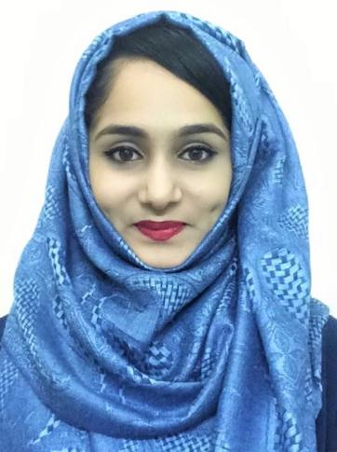

MEHER
MEHER.334510@2freemail.com

OBJECTIVE

To work for an organization which provides me the opportunity to improve my skills and knowledge to growth along with the organization objective.

PROFILE SUMMARY

- An enthusiastic, self-motivated, reliable, responsible and hardworking person. I am able to work well both in a team environment as well as using own initiative.

- A good listener and quick learner, able to communicate well with a group and on individual level.

- A flexible person seeking employment which will allow development, growth and make use of my existing skills.

KEY SKILLS

- Strong motivational and leadership skills.

- Ability to produce best result in pressure situation.

- Excellent communication skills in written and verbal both.

- Ability to work as individual as well as in group.

COMPUTER SKILLS

- MS- word

- MS-Excel

- MS- PowerPoint

- Internet

- FoxPro

- Tally ERP 9

EDUCATION QUALIFICATION

- Completed Bachelors of Business Administration (BBA) from Anjuman Institute of Management and Computer Applications in 2016 with 83%.

- Passed higher secondary from Best Academy in 2013 with 81%.

- Passed high school from Anjuman Girls High School in 2012 with 60%.

- Primary Education at Gulf Indian High School, Dubai, U.A.E.

AWARDS AND ACHIEVEMENTS

- Participated in Management level fest and bagged first position in Management event.

- Participated and won various sports events in college.

- Organized State Level Management fest for Undergraduates.

- Awarded ‘MISS INTELLIGENT’ title in Best Academy.

- Awarded ‘Best Presenter’ in a workshop on Entrepreneurship.

- Students General Secretary (Head girl) during graduation.

2

WORK EXPERIENCE
Organization: MARINA TOURISM L.L.C, DUBAI.

Position: Administrative Services and Sales

- Responding to incoming emails and phone enquiries.

- Maintenance of Office Administration details.

- Handling correspondence Documents and Secretarial works.

- Typing and processing tourist visas and posting in Ledger manually.

- Involved in e-marketing and telemarketing.

- Making quotations for tour packages.

- Listening to customers requirements and presenting appropriately to make a sale.

- Acting as a contact between the company and its existing customers.

- Attending team meetings and recording minutes of meetings.

Organization:

- SHARAF DG in DCC – BRAUN Hair Straightener

- ARABIAN CONCEPT in WTC – RASNA

- PURPLE TREE in AL MAYA – TRANQUINI

Position: Promoter & Demonstrator

- Generating sales by providing outstanding customer service.

- Utilizing special product knowledge.

- Maintaining awareness of all promotional offers and encourages the customer -to avail discounts on the products promoted by the store.

- Responsible in merchandising and display maintenance.

- Offering advice to the customer.

- Maintaining and arranging products availability on the floor of the store.

- Achieving the sales targets assigned by supervisor.

PERSONAL DETAILS
- Date of birth: 28th February 1994.

- Nationality: Indian.

- Visa Status: Residence (Father Sponsorship)

- Marital Status: Single.

- Hobbies: Playing outdoor sports.

- Languages known: English, Hindi, Urdu, Arabic and Kannada.

3

