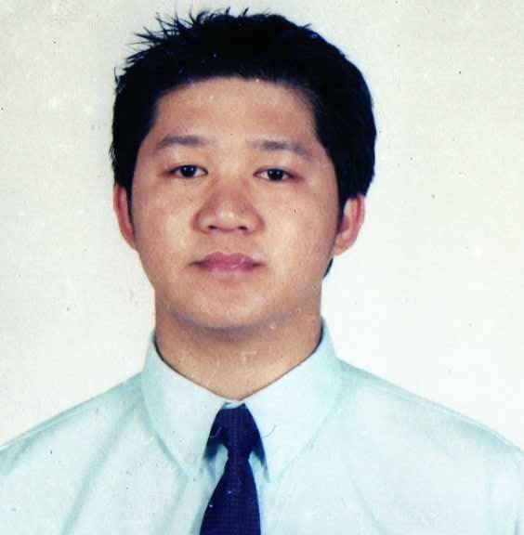
Randy
Randy.334528@2freemail.com

Career Objective

To learn more not only for what I achieved but to communicate in other fields of businesses.

Employment History

Eligibility: Dubai,UAE

Licensed No. Category Level 1,2 & 3
Manual and Automatic Transmission Eligible and Motorcycle Driver

Etiquette for Excellent Customer Service
Spearhead Training
City Seasons Hotel, Deira, Dubai UAE
May 8, 2015

TSI Quality Services Person in Charge Level 3 Award
Certificate Number TSI-QS-PIC
Grand MidWest Hotel Dubai Internet City. Dubai,UAE.
April 2012

Food Safety and hygenical Training Course
Jhonson Diversey
Flora Park Hotel Al Rigga Deira. Dubai, UAE
September 2010

The Salad Jar Llc. Dubai UAE

Employed

Archived Clerk cum Driver

- Deliver a wide variety of items to different addresses and through different routes
- Follow route and time schedule
- Load, unload, prepare, inspect and operate delivery vehicle
- Ask for feedback on provided services and resolve clients’ complaints
- Collect payments
- Inform on new products and services
- Complete logs and reports
- Follow DOT regulations and safety standards.
EMARATECH Dubai, UAE
Zajel Courier Services
May 02, 2013 – July 31, 2015

Courier cum Document Controller

  - Obtain signatures and payments, or arrange for recipients to make payments.

  - Walk, ride bicycles, drive vehicles, or use public conveyances in order to reach destinations to deliver messages or materials.

  - Load vehicles with listed goods, ensuring goods are loaded correctly and taking precautions with hazardous goods.

  - Unload and sort items collected along delivery routes.

  - Receive messages or materials to be delivered, and information on recipients, such as names, addresses, telephone numbers, and delivery instructions, communicated via telephone, two-way radio, or in person.

  - Plan and follow the most efficient routes for delivering goods.

  - Record information, such as items received and delivered and recipients' responses to messages.

  - Deliver messages and items, such as newspapers, documents, and packages, between establishment departments, and to other establishments and private homes.

  - Sort items to be delivered according to the delivery route.

  - Check with home offices after completed deliveries, in order to confirm deliveries and collections and to receive instructions for other deliveries.

  - Perform routine maintenance on delivery vehicles, such as monitoring fluid levels and replenishing fuel.

  - Call by telephone in order to deliver verbal messages.

  - Open, sort, and distribute incoming mail.

  - Perform general office or clerical work such as filing materials, operating duplicating machines, or running errands.
    - Immigration processing new visa, renewal, cancellation and etc.
    - Medical health processing and emirates ids new and renewal applications
    - Governments public documents processing.

  - Collect, seal, and stamp outgoing mail, using postage meters and envelope sealers.

  - Unload goods from large trucks, and load them onto smaller delivery vehicles.

SUBWAY Restaurant, Dubai UAE
Golden Sun Fast food Llc. & Emerald Island Café Llc.
Employment Status : April 21, 2009 – April 21, 2012 & July 17, 2012 – April 24, 2013

Asst. Manager cum Driver

- Responsible for maintenance and operations of the assigned Subway Unit in accordance with established policies and procedures.
- Responsible for the development and implementation of tactics to optimize restaurants sales and cash flows while ensuring adherence to quality, cleanliness and customer service standards as the major component.
- Responsible for restaurants performance levels in the areas of brand delivery, sales, cash flow and controllable costs. Identifies and resolves problem areas in conjunction with the restaurant team.
- Responsible for maintaining zero (0) customer complaints and Unit Full compliance SUBWAY evaluation and Health Inspection.
- Directs restaurant team regarding effective utilization of resources.
- Supervises the operation of the restaurants to ensure that food safety, product preparation, and cleanliness, and sanitation standards.
- Responsible for some variety of duties relating to Quick Service Restaurants (QSR) –style service including greets and serves guest, and light paperwork and inventory control standards are maintained. Also include scheduling and supervising staff. Trains newer sandwich artists in all tasks and responsibilities.

Samsung Electronics Philippines Corporation, Ortigas Philippines
Marketing and Sales Department
February 5, 2007- February 15, 2009

Sales and Marketing cum Merchandiser

- Organizing Samsung mobile exhibits and events promoting Samsung mobile in the market with a newly feautures affordable and a user friendly mobile phone.
- Conducting training to the dealers, retailers and sales representives for how they introduce it Samsung mobile bearing with marketing and sales strategy.
- As field coordinator visiting the outlets and maintaining the eye level position in displays updating the design accordingly to the new models releases in the market.
- Coordinates with the dealers and retailers in the outlets regarding sales and they need for marketing purposes thru merchandising.
- Submitting documentary papers including itinerary for daily task , weekly reporting for the movement or response of the market including sales and dealers,retailers feedback and outlets design also included in the software presentation report.

San Miguel Corporation, Ortigas Pasig City, Philippines
Food and Beverages Section
June 2001-October 2006

Sales Marketing cum Merchandiser

• Routine Sales Call Cycle for Existing Retail Listing.
• Present New Product Introductions/Presentations to retail partners.
• Process and Follow up on all orders as necessary.
• Coordinate demos and trainings as necessary.
• New store opening and store reset support for Natural Food and Specialty Retailers.
• Merchandising and Retail Support for accounts as directed by the Sales Manager.
• Maintain stores sets/testers/merchandising units/displays/product literature as warranted.
• Work with Sales Manager to conduct broker trainings.
• Utilize market data (rankings, sales trends, etc.) to improve placement and retail support.
• Develop relationships at store, wholesale and manufacturer level.
• Support the Team with support for trade shows and special events as necessary.
• Communicate with Sales Manager regarding sales issues/objectives.
• Communicate with Vendor Partners a minimum of 15-20 communiques per week.
• Be courteous and a responsible driver at all times.

Toyota Manila Bay Corporation, Pasay City Philippines
Insurance Section
November 2000-May 2001

Insurance Staff

- Encoding, filling files, updating client’s insurance status.
- Telephone operator inbound and outbound call for insurance premium.
- Field officer delivered motor vehicle insurance premium.
- Collecting payment of insurance premium cash and checks from client’s.

De La Salle University, Philippines
Resources Learning Center
February 1996-March 1998

Library Assistant Officer

- Managing the counter section for Barrowing and Returning Books.
- Responsible for helping the students for their desired books thru alphanumerical order computerally and by section order.
- Encoding, filling of all ordered listed books from the delivery according to their respective catalogs.
- Maintained peace and order inside the library and arranged everything for the convenience and safety of the books from time to time.

Educational Background

Bachelor of Science in Computer Science
June 1997-October 2002: AMA COMPUTER UNIVERSITY.
Regalado Avenue. Barangay Pasong Putik
Novaliches Quezon City, Philippines

Lagro High School
1992 – 1997: Lagro Subdivision Barangay Greater Lagro
Novaliches Quezon City, Philippines

Commonwealth Elementary School
1986-1992: Barangay Commonwealth Commonwealth Avenue.
Quezon City, Philippines

Trainings/Seminars Attended in Philippines

November 2005 Credit Card The Market Demands (LUMINA VISA CARD) seminar sponsored by UNION BANK OF THE PHILIPPINES
- Utility card
- Sales timing
- Marketing strategy
- defeating competitor’s features

December 2001: Bank of the Philippine Islands, Philippines
- Completed 200 hours of Training
- Performs data entry and uses software programs
- Open accounts officer
- performed daily inventory of outcome documented form
- Credit cards selling indoor

June 2000 System Administration Training
- How to download file, uploading file
- maintaining system internet connection
- Microsoft excel fundamentals
- Microsoft word practicing
- Microsoft presentation training
- e-mail interception
- Internet surfing, chat

Character References upon Request and Feel free to contact me.

