JINOOB
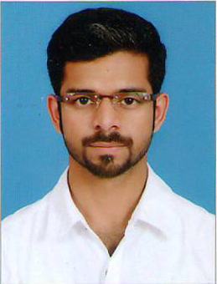
JINOOB.3345434@2freemail.com

OBJECTIVE.
Looking for an opportunity in a prestigious organization where I can expose my experience and ability

- 3 Year Diploma in Hotel Management & Catering Technology
AICTE (All India Council for Technical Education 2006-2009
Oriental School of Hotel Management, Wayanad, Kerala.
- International Diploma in Hospitality Management
AH&LA, USA 2006-2009
Oriental School of Hotel Management, Wayanad, Kerala

HOME CENTRE, LAND MARK GROUPS (Calicut, India)

Duration : 6st Aug 2015 to Still Working
Designation : Supervisor

RESPONSIBILITIES

- Maintain the floor
- Allocate duties for staffs
- Morning briefing and make aware of products and offers to staffs
- Make sure sales target achieved
- Ensure the store items are handling properly
- Maintain the good relationship with all the departments in the smooth manner

HOME CENTRE, LAND MARK GROUPS (Riyadh, KSA)

Duration : 1st may2013 to 31st may 2015
Designation : Sales Associate

RESPONSIBILITIES

- Sales
- Merchandising
- Customer service

EXIDE INDUSTRIES LTD.

Duration : From 1st October 2009 to 31st December 2010
Designation : Commercial assistance

RESPONSIBILITIES

- Customer service
- Office administration
- sales

COMPUTER KNOWLEDGE

- MS-OFFICE

LANGUAGES KNOWN

Malayalam and English - Ability to read, write and to speak
Hindi,Tamil and Arabic – Ability to speak

PERSONAL DETAILS

Sex & Marital status : Male, Married.
Date of Birth : 12-11-1985
Nationality : Indian
Religion : Islam

I hereby declare that the above information’s are true and complete to the best of my knowledge and belief.

