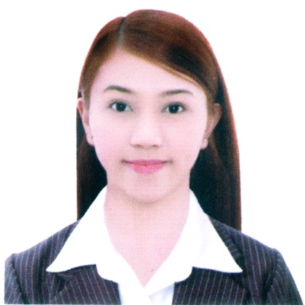
MARGARITA
MARGARITA.334540@2freemail.com

____________________________________________________________________________________
CAREER PROFILE

- Bachelor of Science in Nursing (BSN)
- With Practical Training and Experience in Telecommunication Companies and Documentation
- Knowledgeable in Windows Software and Applications

____________________________________________________________________________
PROFESSIONAL EXPERIENCES

CREDIT ANALYST
Globe Telecom Inc. – Manila, Philippines
May 2016 to December 2016

- Collect customer payments in accordance with payment due dates.
- Provide timely follow-up on payment arrangement.
- Mail correspondence to customers to encourage payment of delinquent accounts.
- Mail documents to accounts and follow-up.

BILLING SPECIALIST
Asticom Technology Inc. – Manila, Philippines
April 2016 to May 2016

- Identify issues attributing to account delinquency and discuss them with management.
- Review and monitor assigned accounts and all applicable reports.

COLLECTION SPECIALIST
Admerex Solutions Inc. – Manila, Philippines
May 2013 to January 2016

- Reviewing active accounts for collection efforts.
- Making outbound collection calls in a professional manner while keeping and improving customer relations.
- Resolves client-billing problems and rescues accounts receivable delinquency, applying good customer service in a timely manner.

AWARDS AND ACHIEVEMENTS

- Top 4 Performer for August 2013, Globe ESC Save Team, October 10, 2013
- Top Collector for December 2013, Globe Corporate Wireline Team, December 2013
- Top Collector for March 2015, Globe Corporate-Wireline Team, March 2015
- Best in QA for November 2013
- Best in QA for February 2014
- Best in QA for June 2014
- Best in QA for February 2015

FIELD RESEARCHER
FlorBacar Consumer Research Services – Manila, Philippines
September 2012 – December 2012

- Collecting of information of particular subject.

CASHIER
Merriam-Webster Bookstore – Manila, Philippines
January 2012 – June 2012

- Collects and records payment.

PHARMACY ASSISTANT cum CASHIER
The Generics Pharmacy – Manila, Philippines
January 2011 – July 2011

- Dispensing medical drugs with prescription of medical doctors.
- Responsible for money received and expended.

____________________________________________________________________________________
PROFESSIONAL TRAININGS

- Collections Training Course, Admerex Solutions Inc., July 15, 2013
- Globe Corporate Training, Admerex Solutions Inc., December 2013
- Time Management Workshop, Globe Telecom Plaza Pioneer, October 27, 2014

____________________________________________________________________________________
SKILLS

- Effective time management
- Analytical mindset
- Great plain knowledge
- Proficiency in Microsoft Office including Excel and Word
- Complex problem solving
- Customer service
- Documentation skills

____________________________________________________________________________________
EDUCATION

Bachelor of Science in Nursing – Diploma
Far Eastern University – Philippines

PERSONAL INFORMATION

Date of Birth: June 23, 1989
Nationality: Filipino

