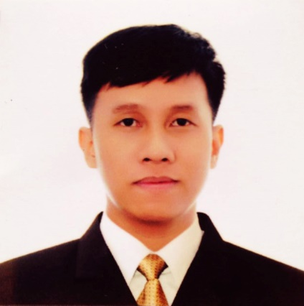
Emmanuel.334541@2freemail.com

EMMANUEL

Work Experience
Freelance Skateboard Filmer Since 2013 - Present
- Filming/Editing Skate Video Clips/Teaser
(

[24]-7 Incorporated (Pasig City, Philippines) Sept 2015 – Jan 2017
Fraud and Data Analyst cum Data Entry
Customer Service Officer
(Kohls Retail/Online Store– USA)
-Addressed general inquiries related to account specific products & services
-Processed price adjustment/matching
-Processed credits and refunds
-Coordinating with different carriers to follow up delivery status
-Processed customer and account source documents by reviewing data for deficiencies; resolving discrepancies by using standard procedures or returning incomplete documents to the team leader for resolution.
-Maintained data entry requirements by following data program techniques and procedures.

Telus International Philippines (Quezon City, Philppines) Sept 2014 – Feb 2015
Customer Service Sales Officer cum Technical Support
Dell Computers USA / Alienware
- Maintained and developed relationships with customers via chat, emails and telephone calls
- Made accurate, rapid cost calculations and providing customers with quotations
- Negotiated the terms of an agreement and closing sales
- Basic customer support for the customers regarding computers/laptops and other Dell products

IBM Global Process Services (Quezon City, Philippines) Aug 2012 – Aug 2014
Customer Service Officer cum Technical Support
Orange Telco – United Kingdom
- Handled all kinds of company queries, Billing and Online Payments
- Provided Technical Support for different Mobile Handsets

Damage Inc. (Caloocan City, Philippines) Jan 2008 – Jul 2012
Audio & Lighting Technical Support / OIC Installation and Set Up
cum Administrative Assistant
- Managed installation/maintenance of Audio & Lighting Equipments
- Provided maintenance and repair for Audio & Lighting Equipment
- Prepared Basic Program for L.E.D lights & Professional Lights
- Provides administration related support to all departments as required
- Liaised with staff in other departments and with external contacts
- Recruited, trained and supervised junior staff and delegating work as required
- Managed the filing, storage and security of documents

Forerunner Technologies Inc /Music Source (Quezon City) Oct 2006 – Nov 2007
Sales Representative cum Office Assistant
- Sales Staff (Guitars, Bass, Drums and other Music Instruments)
- Technical Assistant/Installation for Pro Audio & Pro Lighting Equipments
- Assistant L.E.D. Programmer @ SOP, GMA 7
- Demonstrated Pro Audio & Lighting Equipment to be sold

Education

Technological University of the Philippines 2004 – 2007
(Bachelor of Technology in Electronics Engineering Technology)

Bagong Barrio National High School (Caloocan) 2000 – 2004

Other Qualifications
Ms Office Applications (e.g. Word, Excel, Powerpoint)
Basic Troubleshooting
Photo Editing (Adobe Photoshop)
Video Editing (Sony Vegas Pro 11, 12 and 13 Adobe Premiere Pro, Adobe After Effects)

