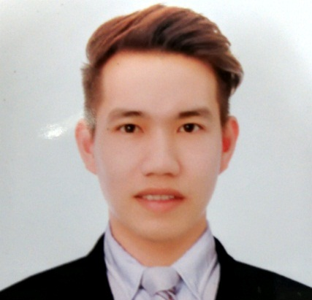

ARIES
ARIES.334546@2freemail.com

- EDUCATIONAL ATTAINMENT

Doctorate Degree: NONE

Masteral Degree: NONE

College: Bachelor of Science in Nursing
Batch 2007
Pamantasan ng Cabuyao
Katapatan Village,Banay-Banay Cabuyao,Laguna

Bachelor of Science in Secondary Education
Major in Biological Science
June – November 2013
Dalubhasaan ng Lungsod ng San Pablo
San Pablo city, Laguna

High School: Pulo National High School
Pulo Cabuyao, Laguna

Elementary: San Isidro Elementary School
Brgy. San Isidro, Cabuyao, Laguna

- WORK EXPERIENCE

August 16,2016 – Present Company Nurse/ HR Staff
Miyoshi Technologies Philippines Inc.
Lot B1-5 Road 6 Carmelray Industrial Park II,Brgy. Tulo Calamba ,Laguna

July 2015 - February 2016 Company Nurse
Panasonic Precision Devices Philippines Corporation
Bldg.2 102 Laguna Blvd., LTI, Bo. Don Jose Sta.Rosa City, Laguna

April 10, 2015 - July 2015 Head Nurse
Emergency Room Dept.
SOUTHERN LUZON HOSPITAL AND MEDICAL CENTER
Sta. Rosa City Laguna

October 10, 2013 – April 10, 2015 Staff Nurse
Emergency Room Department
SOUTHERN LUZON HOSPITAL AND MEDICAL CENTER
Sta. Rosa City Laguna

February 14, 2010- February 14, 2012 Nurse
(RNHEALS)
Registered Nurse for Health Enhancement and Local Services
Department of Health
Sta.Cruz Laguna

August-December, 2012 Nurse Coordinator
Registered Nurses for Health Enhancement and Local Services- Health Emergency Management System)-RNHEALS-HEMS
City Health Office of Sta.Rosa
Sta.Cruz Laguna

- ELIGIBILITY

Passed the Nurses Licensure Examination given by the Professional Regulations Commission, Philippines last November 2009.
License Number: 0608364
Expiry Date: May 07, 2017

- ORGANIZATIONS

Member: Philippine Nurses Association

- OTHER AFFILIATIONS AND EXPERIENCE

Trainee: Intravenous Therapy
New Sinai Hospital
Sta.Rosa City, Laguna

Trainee: Basic Life Support Provider's course
Largado Safety and Rescue Training Center
John the Baptist Hospital, Parian, Calamba, Laguna
Valid until 2017

Trainee: Advanced Cardiac Life Support Provider's course
Largado Safety and Rescue Training Center
John the Baptist Hospital,Parian Calamba, Laguna
Valid until 2017

- PERSONAL DATA

Birthdate: May 7, 1987
Gender: Male
Citizenship: Filipino
Religion: Catholic
Civil Status: Single
Height: 5’ 8”
Weight: 165 pounds

I hereby certify that all the above information is true and correct to the best of my knowledge and belief.

