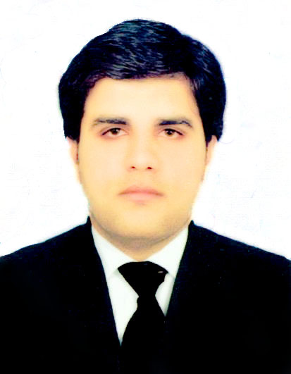
Omer
Omer.334559@2freemail.com

Objective

Seeking a position to leverage my professional qualification and experience to benefit mutual growth and success.

Profile

- Four years of increasing responsible experience in Accounts, Finance and Audit.
- Having experience of preparing accounts up to finalization, well-versed in IAS and IFRS.
- Soft skills Focus 7, Acc Pac, Tally 9, Sage 50,Lotus, Quick Books and MS Office.
- Specialist in Corporate Reporting, Financial Management, Audit, Taxation & Business Analysis.
- Strong analytical, communication, team player, goal oriented and leadership skills.

Professional Experience

Position : Accounts Executive
Organization : Shakeel Ahmed General Trading L.L.C (UAE)
Duration : Jan, 2016 to Present
Company Profile : Company is working in Stationary, House Holding, Newspaper
Publishers, Online Content, News, Beauty products, Cosmetics,

Accomplisments
- Prepare accounts payable aging report through Focus V7, reconciling vendor statements and clearing payments.
- Prepare and post intercompany transactions, issue debit notes and reconcile balances.
- Responsible for day to day management of books of accounts, preparing and posting month end closing journal vouchers.
- Responsible for timely replenishment and reconciliation of petty cash to ensure the availability and accuracy of cash on-hand.
- Analyze individual account information, providing pertinent data to support decision making.
- Contribute to the identification of opportunities for continuous improvement of systems, processes and practices in the Finance department.
- Make recommendations to management for improving systems & controls for efficiency and effectiveness

Position : Accounts Officer
Organization : Ali Akbar Group.
Duration : March, 2014 to Sep 2015 (1 Year and 6 months )
Company Profile : Leading GROUP OF COMPANIES engaged in Agrochemicals
Seeds, PET Bottle, Irrigation System in Pakistan
Accomplishments
- Review, investigate and correct errors and inconsistencies in General Ledger entries, assist Finance Manager in closing process.
- Overseeing the entire accounts payable module, review all invoices for appropriate documentation to make sure that invoices billed to the company are correct.
- Responsible for day to day management of books of accounts, preparing and posting month end closing journal vouchers.
- Prepared accounts payable aging report, reconciling vendor statements and clearing payments.
- Primary contact with banks on day-to-day banking, including changes to signatories and opening and closing of bank accounts.
- Assisted HOD’s in the preparation of reporting to the board of directors.
- Prepared of invoices and Purchase Order.
- Prepared payroll, bank reconciliation statements and accounting of letter of credit.
- Analyzed individual account information, providing pertinent data to support decision making.
- Contributed to the identification of opportunities for continuous improvement of systems, processes and practices in the Finance department.

Position : ACCA Trainee
Organization : Kreston Hyder Bhimji Chartered & Co.
Duration : Dec 2012 to Feb 2014 (1 year and 3 months)
Company Profile : One of the Renowned Accountancy Firm in Lahore Pakistan.

Accomplishments

I have obtained adequate expertise in review of systems and audits of manufacturing, trading, financial and service industries. Nature of services performed includes.
- Review, preparation and compilation of financial statements in accordance with the reporting framework comprising of International Financial Reporting Standards (IFRS) and applicable local laws.
- Carry out audit planning, evaluation of control activities and audit of the financial statements in accordance with the International Standards on Auditing (ISA) and audit guidelines of Kreston International.
- Evaluation of Internal Control System to identify deficiencies in the system and suggesting remedial procedures through Internal Control Memorandum (management letter) to rectify the control weaknesses.
- Review of compliance with applicable laws and regulations.
- Carrying out Agreed-Upon-Procedures and Special assignments.
- Performed the responsibilities of audit supervisor in his absence.

Internship

Pakistan Telecomunication Company Ltd.from Sep, 2012 to Oct, 2012.
Professional Qualification

Chartered Certified Accountant – ACCA (UK) 2015
Qualified

Advanced Diploma in Accounting and Business – ACCA (UK) 2013
Passed
\
Certified Accounting Technician– ACCA (UK) 2009
Passed

Personal Information

Nationality : Pakistani

Date of Birth : December 25, 1988

Languages : English (Fluent), Urdu (Native)

Trainings

- ERP Tally 9, Sage 50, Quick Book from Lahore, Pakistan
- Microsoft Excel by professional trainer.
Reference

- Shall be available on demand.

