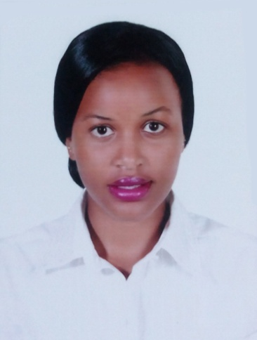
CURRICULUM VITAE

PERSONAL DETAILS:
Name: Leah
Email : Leah.334582@2freemail.com
Gender: Female
Date of birth: 1st June, 1994
Marital status: Single
Nationality: Kenyan
Languages: English and Kiswahili

PERSONAL PROFILE:
I am passionate about the Hospitality industry and my practical experiences serving in different places have confirmed hospitality as the career choice for me. I am looking forward for a career focused on my passion and presenting myself with the opportunity to work with similar like-minded people.
My hard work, enthusiasm, communication skills, responsible and friendly nature are assets I would like to bring to this line of work. I believe that I have the skills and ability to work independently and prioritize things under pressure and able to meet set deadlines.
WORK EXPERIENCE:
Eton Hotel: January 2016 – Current
Hostess
Responsibilities
- Delivering exceptional customer service which involves exceeding customer expectations and resulted in building a well-established customer base.
- Handling business correspondence and holding negotiations on event planning.
- Working together as a team on maintaining outstanding teamwork and a team spirit.
- Successfully meeting and solving challenges in a smooth and positive way.
- Performing cashier activities, working with the payment system, preparing reports for the accountant department;
- Coordination of all activities at the restaurant.
- Upholding high-quality grooming standards

The Oak Place: December 2014 – October 2015
Waitress
Responsibilities:
- Take guest orders and enter it to computers for transmittal to kitchen staff.
- Check guest satisfaction of their meals and take action to correct any problems.
- Serve food and/or beverages to guests; prepare and serve specialty dishes at tables as required.
- Prepare checks that itemize and total meal costs and sales taxes.
- Clear dishes and glasses from tables or counters, and take them to kitchen for cleaning.
- Collect payments from customers.

EDUCATIONAL BACKGROUND:
2013 – 2015: MOUNT KENYA UNIVERSITY
Diploma title: Hospitality Management

2012 (May- August) INSTITUTE OF ADVANCED TECNOLOGY (IAT)
Computer applications

2008 – 2011 KENYA CERTIFICATE OF SECONDARY EDUCATION Moi Girls Secondary School, Kamangu

2006 -2007 KENYA CERTIFICATE OF PRIMARY EDUCATION Bishop Kairu Education Center
SKILLS
Opera System
Sabre System
Customer Care

HOBBIES
Travelling, reading, charity work, swimming and cooking

