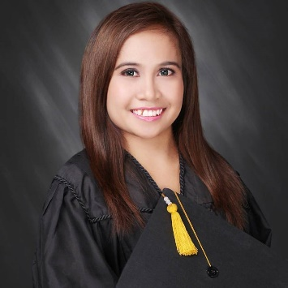
REMMI
REMMI.334610@2freemail.com

OBJECTIVE :
Seeking a position in administration department in which I am given the opportunity to play a direct role in the unlimited growth of my management and administrative skills and the success of a solid organization.

EDUCATION :

College : Bachelor of Science in Business Administration ( major in Business Management ) Central Philippine University, Iloilo City – 2016
High School : 21st Century Private Academy Abu Dhabi, United Arab Emirates – 2012
Elementary School : Pioneers International Private School Abu Dhabi, United Arab Emirates 2008
Trainings / Seminars Attended:
- Four months OJT at Government Service Insurance Systems (GSIS), Iloilo City – November 2015 – March 2016

- Pre-Employment Training Seminar held at Central Philippine University, Iloilo City – February 2016

- APEC SME Summit 2015 “Innovation and Big Ideas: Pushing Boundaries” Live Streaming at Rose Memorial Auditorium, Central Philippine University, Iloilo City – November 17, 2015

- Personality Development and Stress Management at Educational Media Center, Central Philippine University, Iloilo City – September 5, 2015
Skills and Traits:
- Quick learner, Good communication skills, Resourceful, Responsible, Goal oriented, Self-motivated, Computer Literate, Hardworking, Honest and Punctual.
- Computer Literate ( Microsoft words, excel, power point)

Personal Data:

Name : Remmi Status : Single Age : 21 years old Birth Place : Iloilo City Birth Date : January 21, 1995 Weight : 48 kgs Height : 5’0” Religion : Catholic Nationality : Filipino

