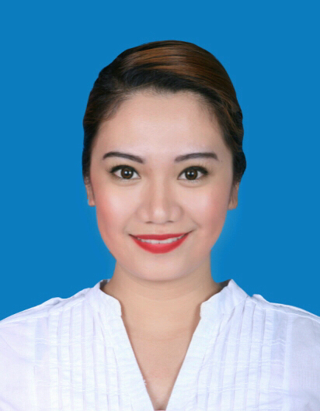
DIANA

DIANA.334613@2freemail.com

Advocacy:
“Transcending development barriers through information-education.”

A dedicated customer relations individual with extensive experience as Patient Administrator in Al Noor Hospital Abu Dhabi; dynamic in terms of work production, being able to easily adopt to situations. Highly motivated to demonstrate excellent work despite stiff deadlines; and understands business and marketing strategies, being a former bank teller in BDO Philippines.

CAREER OBJECTIVE: Excellent job performance, quality work time and productive endeavors – these distinguish me in helping my employer-company meet its goals and be most successful in the world market.

CAREER SUMMARY:

EDUCATIONAL ATTAINTMENT

Baccalaureate: BACHELOR OF BUSINESS ADMINISTRATION,

MAJOR IN BUSINESS MANAGEMENT

QUALIFICATION
Possesses strong command of the English language, effective writing and teaching skills and demonstrates good judgment; a deep understanding of work ethics and a thorough knowledge of basic computer programs, social media concept, including making presentations in various platforms.

EDUCATIONAL BACKGROUND

Bachelor of Science in Business Administration
Major in Business Management
University of the Assumption,
San Fernando Pampanga, Philippines
2004-2008

PERSONAL INFORMATION
Date of Birth: October 1, 1987

Nationality: Filipino

EMPLOYMENT HISTORY

FINANCIAL ADVISOR
PHILAMLIFE (Philippine American Life and General Insurance Company)
San Fernando, Pampanga, Philippines
May 2016-December 2016

Job Description:
- Involves working with clients to understand their short and long-term goals, overall lifestyle and level of risk tolerance, in order to provide tailored advice and develop effective financial plans to meet their financial objectives.

PATIENT ADMINISTRATOR
AL NOOR HOSPITAL, Khalifa Street
Abu Dhabi, UAE
July 2010- November 2015

Duties and Responsibilities:
- Collect patient information/data needed;
- Patient billing, some bookkeeping and other associated administrative tasks;
- Computer work, including familiarity with hospital computer system;
- Processes involving paperwork associated with the patient treatment;
- Communication with patients;
- Dealing with emergencies;
- Dealing with patient complaints;
- Patient appointment system.

BANK TELLER
July 2008 – May 2010
Banco de Oro, Universal Inc.
Makati City, Philippines

Duties and Responsibilities:
- Handling deposits and withdrawals from customers’ accounts;
- Responsible for processing payroll checks;
- Responsible for assisting customers with any business that they might have with the bank, and those with contact with the bank’s administration;
- Assist customers with an array of monetary transactions;
- Keep a careful record of all depositors’ transactions;
- Complete a settlement sheet that tracks all the money processed for the day;
- Sometimes, take responsibility for the bank’s vault and be accountable for all the money and checks that go in and out of it during the day.

DATA ENCODER
Philhealth Insurance Company,
Pampanga, Philippines
July 2007 to September 2007

Duties and Responsibilities:
- Take charge of data entry and transcribing of data into another form, usually through computer programs;
- Process forms of data that clients transcribe, including handwritten documents, information of spreadsheets from another computer program, sequences of numbers, letters and symbols that build a program, or simple data like names and addresses;
- Perform some tasks that are exclusively data entry.

SKILLS
- Excellent interpersonal and communication skills
- Strong Customer Relations skills
- Good command of English language
- Organized and able to work methodically
- Computer Proficiency (Microsoft Word, Microsoft Excel)
- Data Entry Handling
- Proper Telephone Answering
- Word Processing and Typing
- Filing Process

I truly and accurately attest that the information above, along with the data mentioned, are factual and correct to the best of my knowledge and conviction.

