Resume

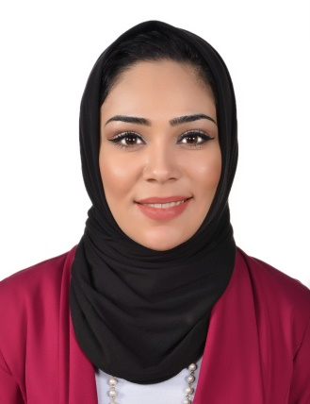

Dima
Dima.334656@2freemail.com

Personal information
Name : Dima
Date of Birth : 25 June 1988
Gender : Female
Nationality : Jordanian
Marital status : Married

EDUCATION:
2008-2012 University of Jordan
Bachelor Degree in Foreign Languages / Italian & English

Skills and QUALIFICATIONS:
- Media Relations, Media Management skills.
- Social Media Skills.
- Event Management.
- Photography, Short film-making.
- Writing; Copywriting skills to edit digital assets.
- In-Design; Adobe skills.
- Strong agency management experience
- Experience of working in a global organization
- Demonstrable understanding and experience of working across languages and cultures.
- Campaign planning, delivery, co-ordination and evaluation.
- Excellent Verbal and Written Communications Skills.
- Excellent Organizational and Analytical Skills.
- Microsoft Office Skills.

PROFESSIONAL EXPERIENCE

United Nations Relief and Works Agency (UNRWA)
Public Information Assistant October 2013-Present

Duties and responsibilities:
- Perform daily media and social media monitoring, and prepare briefs accordingly.
- Media management tasks that include; draft and send press invitations, drat and distribute press releases.
- Ensure media coverage to UNRWA events, through maintaining a regular contact with local and international media representatives.
- Work on UNRWA Publications: designing/ collect and update data/ editing and formatting.
- Branding publications in compliance with UNRWA/ the Organization/ branding guidelines.
- InDesign; that includes designing installations signs, signboards, plaques, flyers, invitations and certificates.
- Write stories and photo features to be posted on UNRWA official website.
- Schedule and take photographs for use in publications as needed; maintain digital photo file.
- Translate press invitations, press releases and human interest stories.
- Assist in planning, coordination, implementation and oversight of special events, such UNRWA’s Advisory Commission meetings, anniversary celebrations, groundbreaking ceremonies, media conferences.
- Maintain and distribute accurate and detailed calendar of events, due date's public relations program.
- Communicate and maintain working relationships with local and international media outlets, productions agencies and with various printing vendors.
- Perform Social Media Implementation for different campaigns, marking annual UN days, advertising UNRWA’s photography competitions, in addition to consistently provide updates, recent news and background information.

Abu Nussair Cultural Forum
Public Relations Coordinator Jul 2012- June 2013

Duties and responsibilities:
- Assist the forum in organizing events.
- Act as a Master of Ceremony.
- Take photograph for the events and write success stories.
- Participate in Aid Programs activities including food donations.
- Participate in several community events.
- Participate in community awareness courses held by the forum.
King Abdullah II Fund for Development
General Assistant Feb 2011 - Dec 2011

Duties and responsibilities:
- Assist in organizing events.
- Act as a Master of Ceremony.
- Participate in organizing courses held by the fund.

University of Jordan library
General Assistant Sep 2010 - Dec 2010

Duties and responsibilities:

- Following up correspondences from international and national organizations.
- Assist the libraries in managing the library.

- TRAINING COURCES

- SAP System training.
- Report Writing.
- Management of Interviews and Talk Shows in Media.
- Computer and Office Applications.
- Montage and Video Editing Training.
- Leadership Training.

LANGUAGES

Arabic – English – Italian

ACHIEVMENTS

