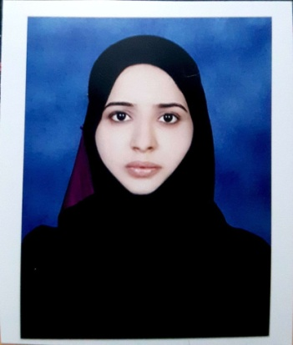

RESUME

NAME: AFREEN
E-mail: AFREEN.334661@2freemail.com

OBJECTIVE

To gain experience in the field of accounting and also utilize my skills, in order to increase productivity of organization and individual growth.

ACADEMIC PROFILE

COURSE | YEARS | INSTITUTION/BOARDS | AGGREGATE
B.COM 3RD YEAR | 2015-16 | KSOU, MYSORE | 65%
B.COM 2ND YEAR | 2012-13 | KSOU, MYSORE | 70%
B.COM 1ST YEAR | 2011-12 | KSOU, MYSORE | 60%
P.U.C | 2007-08 | PPC ADMAR | 80%
S.S.L.C | 2006 | SARASWATHI MANDIRA HIGHSCHOOL UCHILA. | 80%
COMPUTER TEACHER TRAINING COURSE  (DTP,PHOTOSHOP,TALLY ETC) | 2011 | MANIPAL EDUCATIONAL ACADEMY, UDUPI | A⁺

PERSONAL SKILLS

- Comprehensive problem solving abilities.
- Good verbal and written communication skills.
- Willingness to learn, team facilitator and a hard worker. AL TRAIN
- Thorough knowledge of Accounting.
- Ability to deal with people diplomatically.

DEPARTMENT COVERED

Accountant
Computer Operator
Underwriter
Assistant Accountant

WORK EXPERIANCE

Nearly Two year worked as an Accountant and Underwriter in Star Health and Allied Insurance Company Ltd, Udupi.

Rules & responsibilities

- Customer Relationship
- Responsible for achieving & exceeding the customer satisfaction score.
- Responsible for the property in the work area

PERSONAL DETAILS

NTBSGDC
Date of Birth : 25-09-1990
Sex : Female
Marital status : Married
Nationality : INDIAN
Mother Tongue : Urdu
Languages : Kannada, Hindi, English (to Read, Write, Speak), Tulu.

DECLARATION

I hereby declare that all the above facts are true to the best of my knowledge and I will be responsible for any discrepancy.

)

