Dewi Maharani – 2008062
To interview this candidate, please send your company name, vacancy, and salary offered details along with this or other CV Reference Numbers that you may have short listed from http://www.gulfjobseeker.com/employer/cvdatabasepaid.php
addressing to HR Consultant on email: cvcontacts@gulfjobseekers.com
We will contact the candidate first to ensure their availability for your job
and send you the quotation for our HR Consulting Fees.
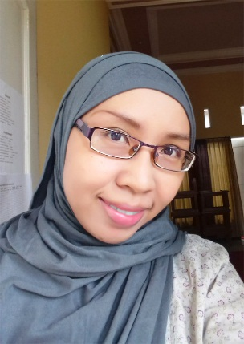

________________________________________________________

Experiences | ICTIGCSE teacher for Primary level - Grade 12based on Cambridge U.K and Singapore curriculum.  (Present)  Surabaya Cambridge School (www.surabayacambridge.sch.id)  ICT teacher for Primary level - Grade 7 based on Cambridge U.K and Singapore curriculum.  (July 2012 – December 2013)  Great Crystal International School (www.great.sch.id)  Teach Primary level – Secondary level based on Cambridge and Singapore curriculum  (September 2009 – October 2010)  (Techno Club Surabaya)  English and Computer Club For Kids  Teach Computer for kids based on Canadian Curriculum  (July 2008 – October 2009)  INIXINDOSurabaya(ProfessionalIT Center)  Freelance IT Instructor for professional  SolindoWeb(Web Developer)(www.solindoweb.com)  Web Architect &Project Manager  (May 2004 – January 2008)
Professional Skills | - Having experience in teaching children using bilingual (English and Bahasa Indonesia).  - Having experience in web tools, e.g. Adobe Photoshop, Adobe Image Ready, Wordpress,Adobe DreamWeaver, Swish, HTML, Pivot Animation, Internet and Microsoft Applications.  - Having experience in Windows 2000, Windows NT, Windows XP operating system and Linux operating system.
Education | - Graduated from Institut Teknologi Pembangunan Surabaya, majoring in Informatics Engineering, 2004. GPA: 3, 08.  - Graduated from Senior High School Pandaan I, Pasuruan, 2000.  - Graduated from Junior High School Gempol I, Pasuruan, 1997.  - Graduated from Elementary School Gempol II, Pasuruan, 1994.
Certificates | - TOEFL certificate  - Linux administrator certificate
Seminar/Training/  Workshops Attended | Cambridge Horizons Seminar on “Bilingual Education: Cognitive Benefits and Policy into Practice  Participant , Surabaya Cambridge School  Surabaya, Indonesia. (November 27, 2012)  Seminar-Workshop on Computer Literacy as Facilitator, Surabaya Cambridge School. (September 17-18, 2012)
Interests and Hobbies | Information Technology, Reading, Art and Philosophy.

I certify that all information given in the application is to my knowledge true and correct. I agree that any false answers or omission of facts shall render this application liable to immediate cancellation or to dismissal from service if I have been employed.
Dewi Maharani, S.T.

Dewi Maharani – 2008062
To interview this candidate, please send your company name, vacancy, and salary offered details along with this or other CV Reference Numbers that you may have short listed from http://www.gulfjobseeker.com/employer/cvdatabasepaid.php
addressing to HR Consultant on email: cvcontacts@gulfjobseekers.com
We will contact the candidate first to ensure their availability for your job
and send you the quotation for our HR Consulting Fees.

