NASIF
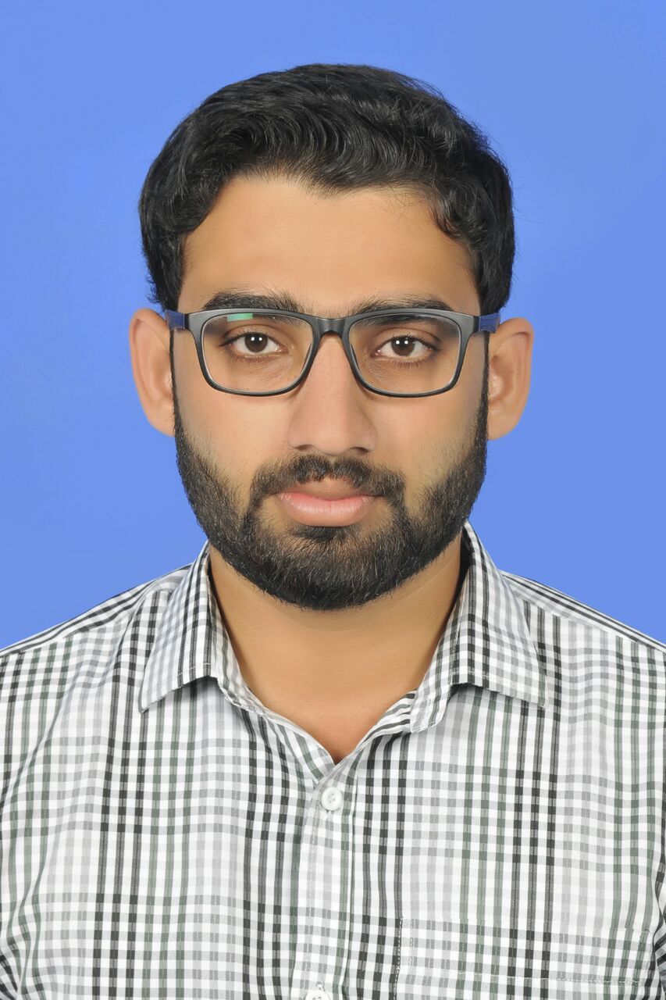
NASIF.334752@2freemail.com
(BTech in Electronic & Communication)

CAREER OBJECTIVE
To obtain a challenging career that demands the best of my professional ability in terms of technical and analytical skills. To utilize and apply my leadership qualities and communication skills which provides me job satisfaction, self-development and enables me as a graduate to grow while fulfilling organizational goals.

ORGANIZATIONAL EXPERIENCE
- Next Education India (P) Ltd
It is an educational company concentrated in K12 sector, their products like Teach Next, LearnNext, Next books, Next ERP etc. are well known in market.
Designation: Technical Support Engineer
Duration: 5 Months
Job profile: My duty was to provide technical support for Next Education products in my district, especially for TeachNext (Digital Class room), new installations, attending complaints in the client schools
- Prometric.
It is a US based test administration company. Prometric operates a test center network composed of thousands of sites in 160 countries.
Designation: Junior engineer
Duration: 30 days
Job profile: My duty was to provide technical support and assistance to run the exams smoothly

CORE COMPETENCIES
- Hardware – Installation of OS, Troubleshooting all kinds of hardware and software related issues, Outlook configuration, Knowledge in using remote access and remote assistance, Operating System troubleshooting.
- Networking – N+ and CCNA R&S – Very good knowledge in IP addressing, Sub netting, Straight through and Cross over cabling and Crimping, Switch configuration, Knowledge in creating and managing VLAN, Routing protocols like RIP, OSPF, EIGRP etc.. , Configuration of DHCP and DNS.
- MCSA- Microsoft Certified Solution Associate – Installing and configuring Windows Server 2012, Administering Windows Server 2012 and Configuring advanced Windows Server 2012 services and features.
- Knowledge of circuits and their methodologies is much important in electronics and communication engineering. I own skills in circuit implementation, electronic components, programming and presentation. I possess good knowledge about processors like 8051, PIC16F877A and 8086/8088. I am well experienced in packages used like MATLAB 10.8V and 2013 Model Sim 6.3a. I am well used to simulation software like Proteus.

CERTIFICATIONS
- Certificate course on Hardware & Networking from CMS IT Training Institute, Bangalore
- Cisco Certified Network Associate (CCNA) globally certified

ACADEMICS
- BTech in Electronics and Communication engineering from Jawaharlal college of engineering and technology, Calicut university, in April 2015 with 65%
- Senior secondary in science stream with math and computer science from Mount Seena public school, CBSE, march 2010 with 68%.
- Higher secondary from Mount Seena public school, CBSE, march 2008 with 78%.

ACADEMIC PROJECTS UNDER TAKEN
Major project (March 2015)
Title: RFID technology and sensor based intelligent vehicle safety system
Period: 45 days
Objective: To ensure the safety from road accidents by creating an intelligent vehicle.
Minor project (April 2014)
Title: Zonal identification system
Period: 25 days
Objective: To help to identify the zones that a vehicle travels.

PERSONAL QUALITIES
- Professional demeanor
- Self starter
- Self directed
- Service minded
- Strong communication skills
- Dedicated team player
- IT skills: - knowledge in MS Office, Windows, Linux and Adobe Photoshop and languages like C, C++ and embedded C.
- The capacity to make quick but rational decisions

PERSONAL DETAILS
Date of birth: 27/05/1992
Languages known: English, Hindi, Malayalam, Tamil

DECLARATION
I hereby declare that the information furnished above is true to the best of my knowledge. I would truly prove myself and would sincerely serve my best for the growth of the organization.
Place: UAE

Date:

