CURRICULUM VITAE
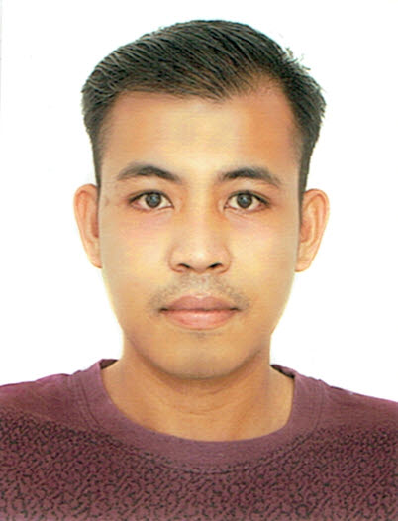

Updated On : January 17, 2016
Name : Romeo
Romeo.334754@2freemail.com

PERSONAL DETAILS

- Date of Birth : April 13, 1991
- Age : 25 years old
- Gender : Male
- Nationality : Filipino
- Marital Status : Single
- Religion : Catholic
- Height : 5 feet 7 inches
- Weight : 149 lbs.

EDUCATION

- Course : Bachelor of Science inNursing
Dates Attended :June 2, 2008 – March 30, 2012
Completion Date : March 30, 2012
School :Aldersgate College
Address :Solano, Nueva Vizcaya 3709 Philippines

PROFESSIONAL LICENSE

- Licensing Body : Professional Regulation Commission
Professional Status :Registered Nurse
Registration Date : February 27, 2013
Validity Date :April 13, 2019

- Licensing Body :Health Authority-Abu Dhabi (HAAD)
Professional Status :Registered Nurse
Registration Date :
Validity Date : N/A

WORK HISTORY

- Duration of Employment : January 2, 2014 -present
Name of Hospital :Veterans Regional Hospital
Address :Brgy. Magsaysay, Bayombong,
Nueva Vizcaya 3700 Philippines
Bed Capacity : 200 beds
Unit :Emergency Room
Position : Staff Nurse

- Hospital and Unit Description:

A 200-bed capacity national hospital and tertiary level teaching and training institution. The hospital mission is to provide quality, affordable and accessible healthcare at all especially the poor. The hospital gives highest important to all matters related to health, safety, quality and environment. The management implement the Hospital Quality Policy which provides quality, safe and cost-effective health care services and ensure efficiency of resource utilization, quality management system and regular monitoring and evaluation. The Emergency Room consists of 3 major station Surgery, Medicine and Pedia that renders medical and surgical management needed by the patients. Works with the other health care providers and assisting patients for admission.

Job Description:

Works with other health care provider to provide quality, safe patient care. My duties and responsibilities are:

- To maintain high quality standards of service in the delivery of nursing care in advocacy to patients’ rights and needs.
- Coordinate the delivery of health services within a multi-disciplinary health team.
- Interpret the goals and objectives of the institution within the context of the nursing practice while rendering service in accordance to set hospital protocols and policies.
- To identify needs, priorities and problems of patients, formulate the nursing component of the comprehensive health plan, interpret and implement the health plan and provide a thorough evaluation of the efficiency and efficacy the health plan according to patient outcomes.
- Render patient specific nursing care with efficiency utilizing academic knowledge and skilled nursing techniques and in accordance to hospital protocols and policies.
- Assist in the coordination and organization of the work force, resources, equipment and supplies in the delivery of health care services.
- Assist physician in the performance of the patient- specific procedures or diagnostics utilizing high standards of care while maintaining patient comfort and ensuring confidentiality.
- Perform accurate documentation and recording of patient’s information, healthcare services rendered and outcomes, maintaining security and confidentiality.
- Act as change agent in motivating changes in health behavior of the patient’s, including lifestyle to promote and maintain health.
- Facilitate continuity of patient care through proper referrals and endorsements to other relevant institutions.
- Maintain high quality standards of one’s nursing skills and knowledge through continuous learning and/ or post qualification education or advancements.

- Equipment Used:

- Defibrillator (Mindray)
- Cardiac Monitors (Mindray)
- ECG machine
- Portable Doppler machine
- Ventilators (Heyer)
- Infusion pump (Hospira)
- Syringe pump
- Feeding Pump
- Portable Pulse Oximeter
- Nebulizer Machine

AFFILIATIONS

- Philippine Nurses’ Association
- Association of Nursing Service Administrators of the Philippines, Inc

TRAININGS ATTENDED

- Certification : Basic Life Support Training Update-Health Care Providers
Date Attended : August 5, 2016
Venue : 4th Floor Trauma Building, Veterans Regional Hospital,
Bayombong, Nueva Vizcaya, Philippines

- Certification : Managing Pitfalls in Intravenous Therapy
Date Attended : May 27, 2016
Venue : Conference Hall, 4th Floor, Trauma Building, Veterans Regional Hospital,
Bayombong, Nueva Vizcaya, Philippines

- Certification : Safety Practices for Healthcare Professionals (Contamination)
Date Attended : May 26, 2016
Venue : Conference Hall, 4th Floor, Trauma Building, Veterans Regional Hospital,
Bayombong, Nueva Vizcaya, Philippines

- Certification : Intravenous Therapy Documentation
Date Attended : May 25, 2016
Venue :Conference Hall, 4thFloor, Trauma Building, Veterans Regional Hospital,
Bayombong, Nueva Vizcaya, Philippines

- Certification : First Respondent Training Course-Basic Rescue Technique
Date Attended : November 25-27, 2015
Venue :Chemiauril’s Pavilion Training Center, Mt. Ynordenan, Bone South,
Aritao, Nueva Vizcaya, Philippines

- Certification : Basic Life Support Training Update-Health Care Providers
Date Attended : August 5, 2016
Venue : 4th Floor Trauma Building, Veterans Regional Hospital,
Bayombong, Nueva Vizcaya, Philippines

- Certification : Regular IV Training Program
Date Attended : April 4-6, 2013
Venue : PLTCI-LUIS A. TIAM MEDICAL CENTER, Bascaran, Solano,
Nueva Vizcaya, Philippines

